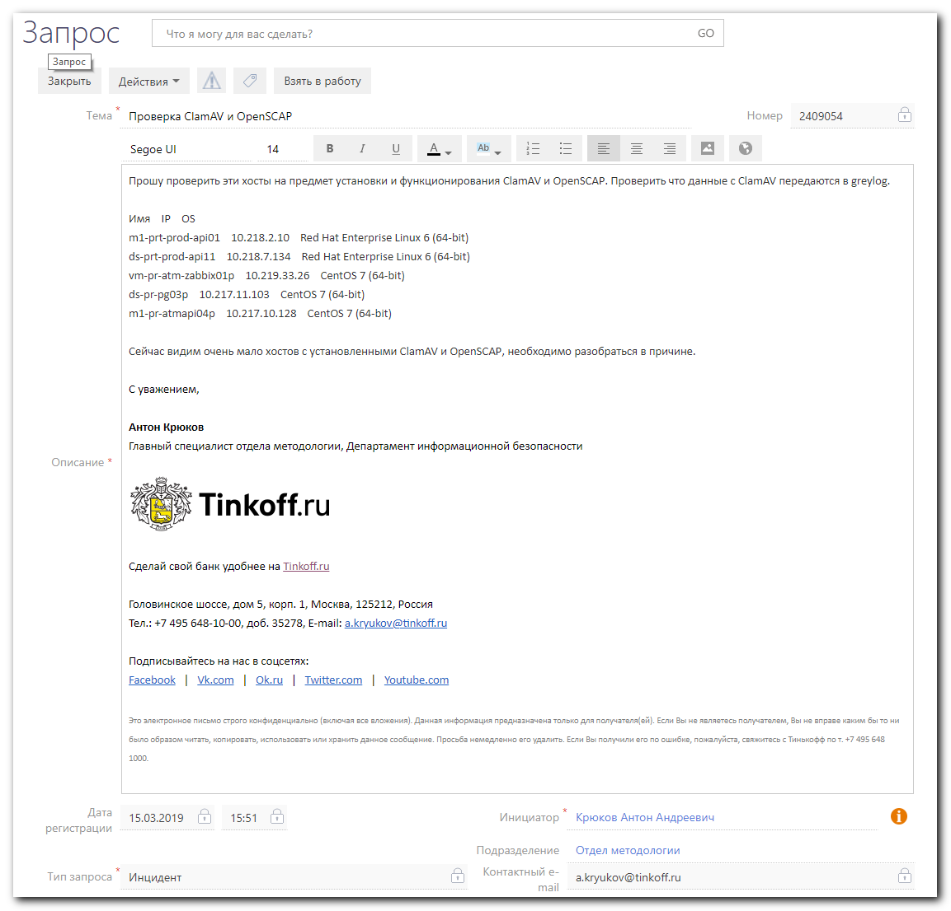
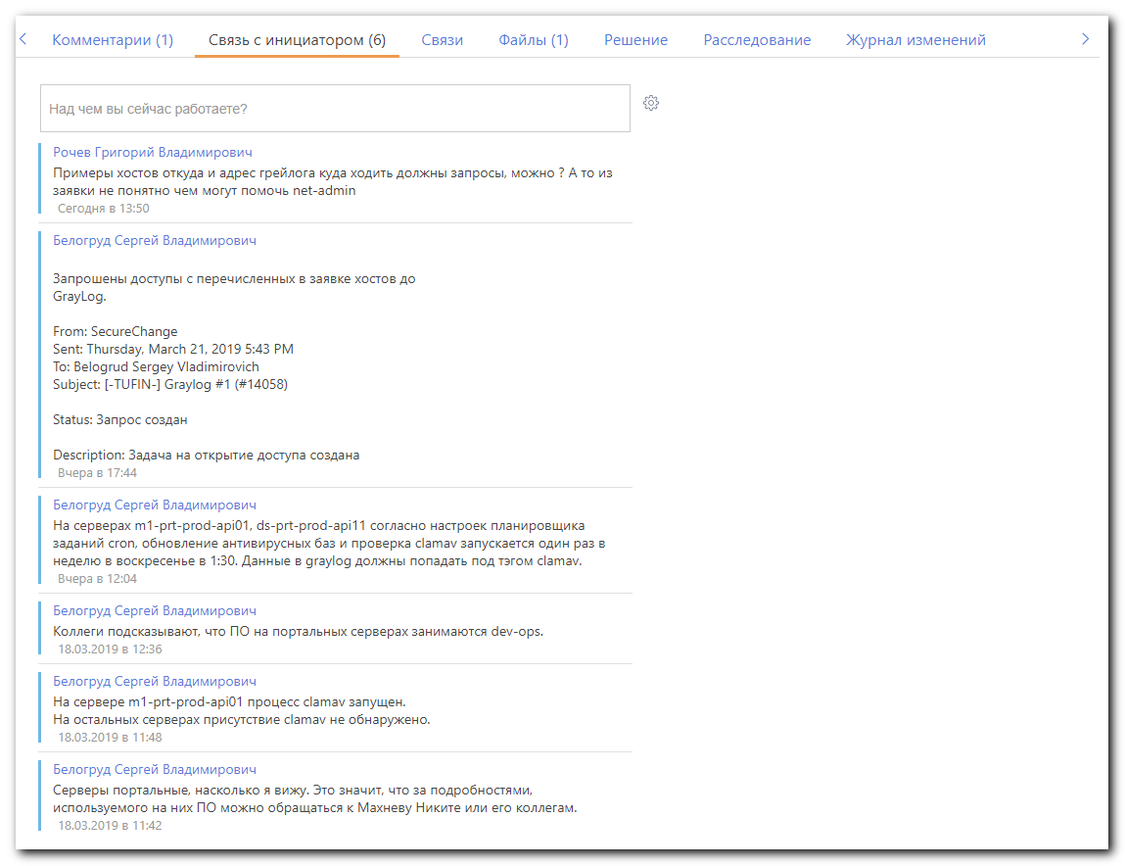
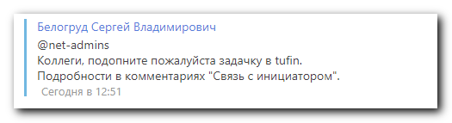

#
# Here is a place, where could be found ansible playbooks, used wide of devops and other.
https://stash.tcsbank.ru/repos?visibility=public
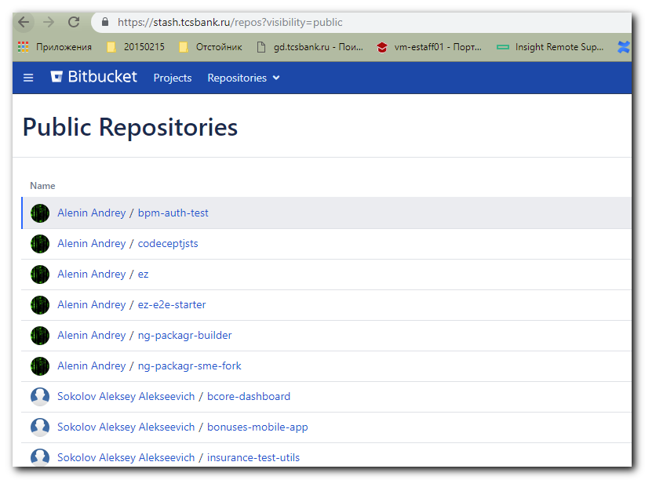

# Here is a place, where Jet made something similar.
https://gitlab.tcsbank.ru/jet/ansible/tree/master/roles/clamav
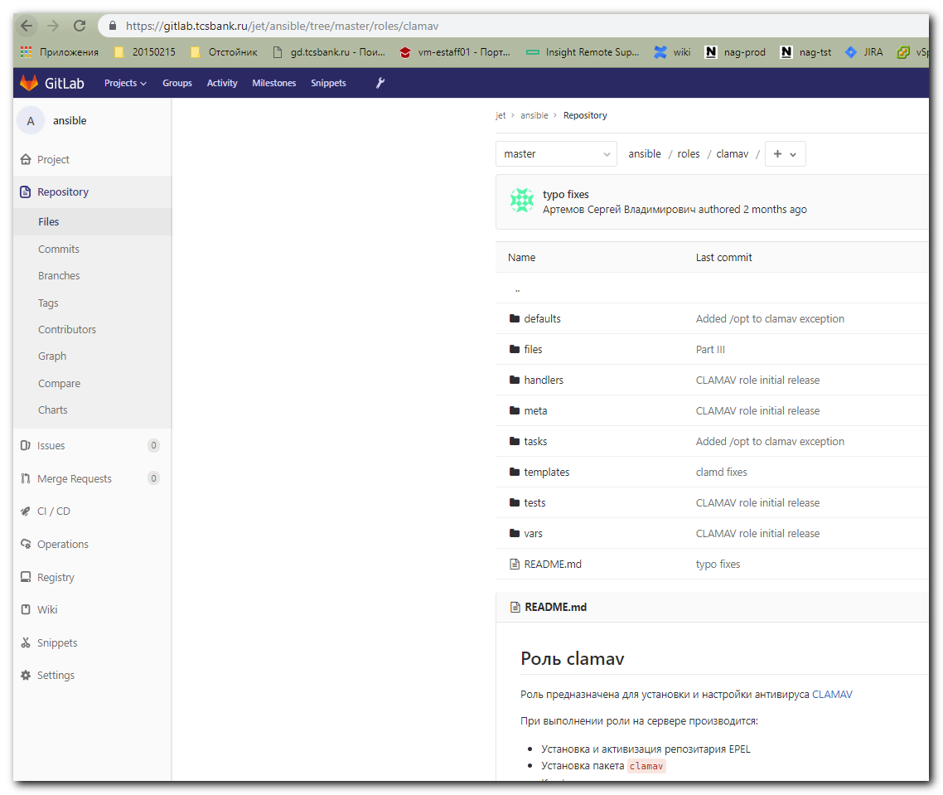

#
# I’ve downloaded playbook archive and extract it.
[s.belogrud@TCS4357]# cp /drives/c/Users/s.belogrud/Downloads/clamav-master\@b4ac4548e2e.zip /drives/c/share/

[support@centos 20190320-1619]$ pwd
/home/support/work/20190320-1619
[support@centos 20190320-1619]$

# To use this play book tree structure - it’s need to create main directories roles/clamav.
[support@centos 20190320-1619]$ mkdir -p roles/clamav
[support@centos 20190320-1619]$ cd roles/clamav
[support@centos clamav]$ unzip ../../clamav-master@b4ac4548e2e.zip
Archive: ../../clamav-master@b4ac4548e2e.zip
b4ac4548e2e46e5de304fe9800b0cfd8cff95179
inflating: README.md
creating: defaults/
inflating: defaults/main.yml
creating: meta/
inflating: meta/main.yml
inflating: requirements.yml
creating: tasks/
inflating: tasks/logs.yml
inflating: tasks/main.yml
creating: templates/
creating: templates/etc/
creating: templates/etc/clamav/
inflating: templates/etc/clamav/freshclam.conf.j2
creating: templates/etc/logrotate.d/
inflating: templates/etc/logrotate.d/clamav.logrotate.j2
[support@centos clamav]$

[support@centos clamav]$ cd ../..

[support@centos 20190320-1619]$ ll
total 16
-rwxrwxr-x. 1 support support 4791 Mar 20 16:20 clamav-master@b4ac4548e2e.zip
-rw-rw-r--. 1 support support 24 Mar 20 19:27 list_of_hosts
drwxrwxr-x. 2 support support 112 Mar 21 11:27 output
-rw-rw-r--. 1 support support 50 Mar 20 19:31 playbook.yml
drwxrwxr-x. 3 support support 20 Mar 21 11:25 roles
[support@centos 20190320-1619]$

# This playbook main file need to be created.
[support@centos 20190320-1619]$ cat playbook.yml
- hosts: all
become: true
roles:
- clamav
[support@centos 20190320-1619]$

# As we can see one role need to be downloaded too.
[support@centos 20190320-1619]$ ansible-playbook playbook.yml -i list_of_hosts --become --extra-vars "ansible_user=bsv ansible_password=$(pass common/linux) ansible_sudo_pass=$(pass common/linux) ansible_ssh_common_args='-oStrictHostKeyChecking=no -oPubkeyAuthentication=no'" --check | tee -a ./output/$(date +%Y%m%d-%H%M).playbook.txt
ERROR! the role 'graylog-collector-sidecar' was not found in /home/support/work/20190320-1619/roles:/home/support/.ansible/roles:/usr/share/ansible/roles:/etc/ansible/roles:/home/support/work/20190320-1619/roles:/home/support/work/20190320-1619

The error appears to have been in '/home/support/work/20190320-1619/roles/clamav/meta/main.yml': line 31, column 5, but may
be elsewhere in the file depending on the exact syntax problem.

The offending line appears to be:

dependencies:
- src: https://stash.tcsbank.ru/scm/ans_int/graylog-collector-sidecar.git
^ here
[support@centos 20190320-1619]$

[support@centos 20190320-1619]$ vim -c ":set nu" /home/support/work/20190320-1619/roles/clamav/meta/main.yml

1 ---
2 galaxy_info:
3 author: definitelynotgeerlingguy
4 description: ClamAV installation and configuration.
5 company: "Midwestern Mac, LLC"
6 license: "license (BSD, MIT)"
7 min_ansible_version: 2.4
8 platforms:
9 - name: EL
10 versions:
11 - 6
12 - 7
13 - name: Ubuntu
14 versions:
15 - trusty
16 - xenial
17 - bionic
18 - name: Debian
19 versions:
20 - jessie
21 - stretch
22 galaxy_tags:
23 - networking
24 - cloud
25 - security
26 - antivirus
27 - antimalware
28 - scan
29
30 dependencies:
31 - src: https://stash.tcsbank.ru/scm/ans_int/graylog-collector-sidecar.git
32 version: "master"
33 scm: git
34 name: graylog-collector-sidecar

# I’ve downloaded the role and placed it in appropirate place.
[support@centos 20190320-1619]$ git clone https://stash.tcsbank.ru/scm/ans_int/graylog-collector-sidecar.git
Cloning into 'graylog-collector-sidecar'...
remote: Counting objects: 130, done.
remote: Compressing objects: 100% (109/109), done.
remote: Total 130 (delta 60), reused 0 (delta 0)
Receiving objects: 100% (130/130), 14.34 KiB | 0 bytes/s, done.
Resolving deltas: 100% (60/60), done.
[support@centos 20190320-1619]$ ll
total 16
-rwxrwxr-x. 1 support support 4791 Mar 20 16:20 clamav-master@b4ac4548e2e.zip
drwxrwxr-x. 10 support support 134 Mar 21 11:30 graylog-collector-sidecar
-rw-rw-r--. 1 support support 24 Mar 20 19:27 list_of_hosts
drwxrwxr-x. 2 support support 112 Mar 21 11:27 output
-rw-rw-r--. 1 support support 50 Mar 20 19:31 playbook.yml
drwxrwxr-x. 3 support support 20 Mar 21 11:25 roles
[support@centos 20190320-1619]$ ll graylog-collector-sidecar/
total 4
drwxrwxr-x. 2 support support 22 Mar 21 11:30 defaults
drwxrwxr-x. 2 support support 22 Mar 21 11:30 handlers
drwxrwxr-x. 2 support support 22 Mar 21 11:30 meta
-rw-rw-r--. 1 support support 1441 Mar 21 11:30 README.md
drwxrwxr-x. 2 support support 74 Mar 21 11:30 tasks
drwxrwxr-x. 2 support support 38 Mar 21 11:30 templates
drwxrwxr-x. 2 support support 39 Mar 21 11:30 tests
drwxrwxr-x. 2 support support 22 Mar 21 11:30 vars
[support@centos 20190320-1619]$

[support@centos 20190320-1619]$ mv graylog-collector-sidecar/ roles/
[support@centos 20190320-1619]$ ll roles/
total 0
drwxrwxr-x. 6 support support 105 Mar 21 11:25 clamav
drwxrwxr-x. 10 support support 134 Mar 21 11:30 graylog-collector-sidecar
[support@centos 20190320-1619]$

# Here I’ve attempted to run playbook again.
[support@centos 20190320-1619]$ ansible-playbook playbook.yml -i list_of_hosts --become --extra-vars "ansible_user=bsv ansible_password=$(pass common/linux) ansible_sudo_pass=$(pass common/linux) ansible_ssh_common_args='-oStrictHostKeyChecking=no -oPubkeyAuthentication=no'" --check | tee -a ./output/$(date +%Y%m%d-%H%M).playbook.txt

PLAY [all] *******************************************************************************************************************************************************************************************

TASK [Gathering Facts] *******************************************************************************************************************************************************************************
ok: [ds-prt-prod-api11]

TASK [graylog-collector-sidecar : set_fact] **********************************************************************************************************************************************************
ok: [ds-prt-prod-api11]

TASK [graylog-collector-sidecar : Setting graylog server url (prod)] *********************************************************************************************************************************
skipping: [ds-prt-prod-api11]

TASK [graylog-collector-sidecar : Setting graylog server url (test)] *********************************************************************************************************************************
ok: [ds-prt-prod-api11]

TASK [graylog-collector-sidecar : Initialize an empty list for our strings] **************************************************************************************************************************
skipping: [ds-prt-prod-api11]

TASK [graylog-collector-sidecar : Append string to list] *********************************************************************************************************************************************

TASK [graylog-collector-sidecar : Concatenate the graylog tags] **************************************************************************************************************************************
skipping: [ds-prt-prod-api11]

TASK [graylog-collector-sidecar : Ensures /etc/graylog/collector-sidecar/ dir exists] ****************************************************************************************************************
ok: [ds-prt-prod-api11]

TASK [graylog-collector-sidecar : generate the configuration of graylog-sidecar] *********************************************************************************************************************
ok: [ds-prt-prod-api11]

TASK [graylog-collector-sidecar : include_tasks] *****************************************************************************************************************************************************
included: /home/support/work/20190320-1619/roles/graylog-collector-sidecar/tasks/RedHat_install.yml for ds-prt-prod-api11

TASK [graylog-collector-sidecar : Initialize an empty var for sidecar current version] ***************************************************************************************************************
ok: [ds-prt-prod-api11]

TASK [graylog-collector-sidecar : Check sidecar current version] *************************************************************************************************************************************
skipping: [ds-prt-prod-api11]

TASK [graylog-collector-sidecar : populate service facts] ********************************************************************************************************************************************
skipping: [ds-prt-prod-api11]

TASK [graylog-collector-sidecar : Initialize an empty var for sidecar current service status] ********************************************************************************************************
fatal: [ds-prt-prod-api11]: FAILED! => {"msg": "The task includes an option with an undefined variable. The error was: 'dict object' has no attribute 'services'\n\nThe error appears to have been in '/home/support/work/20190320-1619/roles/graylog-collector-sidecar/tasks/RedHat_install.yml': line 17, column 3, but may\nbe elsewhere in the file depending on the exact syntax problem.\n\nThe offending line appears to be:\n\n\n- name: Initialize an empty var for sidecar current service status\n ^ here\n"}
to retry, use: --limit @/home/support/work/20190320-1619/playbook.retry

PLAY RECAP *******************************************************************************************************************************************************************************************
ds-prt-prod-api11 : ok=7 changed=0 unreachable=0 failed=1

[support@centos 20190320-1619]$
# Cannot remember, what was trouble in this case and how I’ve fixed it.

# Next difficulties are follow.
[support@centos 20190320-1619]$ ansible-playbook playbook.yml -i list_of_hosts --become --extra-vars "ansible_user=bsv ansible_password=$(pass common/linux) ansible_sudo_pass=$(pass common/linux) an
sible_ssh_common_args='-oStrictHostKeyChecking=no -oPubkeyAuthentication=no'" | tee -a ./output/$(date +%Y%m%d-%H%M).playbook.txt

PLAY [all] *******************************************************************************************************************************************************************************************

TASK [Gathering Facts] *******************************************************************************************************************************************************************************
ok: [vm-pr-atm-zabbix01p]

TASK [graylog-collector-sidecar : set_fact] **********************************************************************************************************************************************************
ok: [vm-pr-atm-zabbix01p]

TASK [graylog-collector-sidecar : Setting graylog server url (prod)] *********************************************************************************************************************************
skipping: [vm-pr-atm-zabbix01p]

TASK [graylog-collector-sidecar : Setting graylog server url (test)] *********************************************************************************************************************************
ok: [vm-pr-atm-zabbix01p]

TASK [graylog-collector-sidecar : Initialize an empty list for our strings] **************************************************************************************************************************
skipping: [vm-pr-atm-zabbix01p]

TASK [graylog-collector-sidecar : Append string to list] *********************************************************************************************************************************************

TASK [graylog-collector-sidecar : Concatenate the graylog tags] **************************************************************************************************************************************
skipping: [vm-pr-atm-zabbix01p]

TASK [graylog-collector-sidecar : Ensures /etc/graylog/collector-sidecar/ dir exists] ****************************************************************************************************************
ok: [vm-pr-atm-zabbix01p]

TASK [graylog-collector-sidecar : generate the configuration of graylog-sidecar] *********************************************************************************************************************
ok: [vm-pr-atm-zabbix01p]

TASK [graylog-collector-sidecar : include_tasks] *****************************************************************************************************************************************************
included: /home/support/work/20190320-1619/roles/graylog-collector-sidecar/tasks/RedHat_install.yml for vm-pr-atm-zabbix01p

TASK [graylog-collector-sidecar : Initialize an empty var for sidecar current version] ***************************************************************************************************************
ok: [vm-pr-atm-zabbix01p]

TASK [graylog-collector-sidecar : Check sidecar current version] *************************************************************************************************************************************
ok: [vm-pr-atm-zabbix01p]

TASK [graylog-collector-sidecar : populate service facts] ********************************************************************************************************************************************
ok: [vm-pr-atm-zabbix01p]

TASK [graylog-collector-sidecar : Initialize an empty var for sidecar current service status] ********************************************************************************************************
ok: [vm-pr-atm-zabbix01p]

TASK [graylog-collector-sidecar : Initialize an empty var for sidecar current service status] ********************************************************************************************************
ok: [vm-pr-atm-zabbix01p]

TASK [graylog-collector-sidecar : Set var for sidecar current service status] ************************************************************************************************************************
skipping: [vm-pr-atm-zabbix01p] => (item=sshd-keygen.service)
skipping: [vm-pr-atm-zabbix01p] => (item=systemd-machine-id-commit.service)
skipping: [vm-pr-atm-zabbix01p] => (item=iprinit.service)
skipping: [vm-pr-atm-zabbix01p] => (item=systemd-readahead-collect.service)
skipping: [vm-pr-atm-zabbix01p] => (item=systemd-nspawn@.service)
skipping: [vm-pr-atm-zabbix01p] => (item=htcacheclean.service)
skipping: [vm-pr-atm-zabbix01p] => (item=plymouth-kexec.service)
skipping: [vm-pr-atm-zabbix01p] => (item=systemd-update-utmp-runlevel.service)
skipping: [vm-pr-atm-zabbix01p] => (item=tcsd.service)
skipping: [vm-pr-atm-zabbix01p] => (item=plymouth-halt.service)
skipping: [vm-pr-atm-zabbix01p] => (item=dracut-pre-mount.service)
skipping: [vm-pr-atm-zabbix01p] => (item=nfs-mountd.service)
skipping: [vm-pr-atm-zabbix01p] => (item=postgresql-9.6.service)
skipping: [vm-pr-atm-zabbix01p] => (item=nrpe.service)
skipping: [vm-pr-atm-zabbix01p] => (item=cpupower.service)
skipping: [vm-pr-atm-zabbix01p] => (item=systemd-readahead-done.service)
skipping: [vm-pr-atm-zabbix01p] => (item=rpc-rquotad.service)
skipping: [vm-pr-atm-zabbix01p] => (item=ntpd.service)
skipping: [vm-pr-atm-zabbix01p] => (item=systemd-shutdownd.service)
skipping: [vm-pr-atm-zabbix01p] => (item=plymouth-quit-wait.service)
skipping: [vm-pr-atm-zabbix01p] => (item=nfs-lock.service)
skipping: [vm-pr-atm-zabbix01p] => (item=blk-availability.service)
skipping: [vm-pr-atm-zabbix01p] => (item=firewalld.service)
skipping: [vm-pr-atm-zabbix01p] => (item=emergency.service)
skipping: [vm-pr-atm-zabbix01p] => (item=nfs-rquotad.service)
skipping: [vm-pr-atm-zabbix01p] => (item=dracut-shutdown.service)
skipping: [vm-pr-atm-zabbix01p] => (item=zabbix-server.service)
skipping: [vm-pr-atm-zabbix01p] => (item=console-getty.service)
skipping: [vm-pr-atm-zabbix01p] => (item=serial-getty@.service)
skipping: [vm-pr-atm-zabbix01p] => (item=rpcbind.service)
skipping: [vm-pr-atm-zabbix01p] => (item=arp-ethers.service)
skipping: [vm-pr-atm-zabbix01p] => (item=systemd-initctl.service)
skipping: [vm-pr-atm-zabbix01p] => (item=nscd.service)
skipping: [vm-pr-atm-zabbix01p] => (item=systemd-halt.service)
skipping: [vm-pr-atm-zabbix01p] => (item=systemd-firstboot.service)
skipping: [vm-pr-atm-zabbix01p] => (item=rdisc.service)
skipping: [vm-pr-atm-zabbix01p] => (item=systemd-kexec.service)
skipping: [vm-pr-atm-zabbix01p] => (item=systemd-rfkill@.service)
skipping: [vm-pr-atm-zabbix01p] => (item=auth-rpcgss-module.service)
skipping: [vm-pr-atm-zabbix01p] => (item=nfs-idmap.service)
skipping: [vm-pr-atm-zabbix01p] => (item=rpcidmapd.service)
skipping: [vm-pr-atm-zabbix01p] => (item=rhel-dmesg.service)
skipping: [vm-pr-atm-zabbix01p] => (item=tuned.service)
skipping: [vm-pr-atm-zabbix01p] => (item=microcode.service)
skipping: [vm-pr-atm-zabbix01p] => (item=vgauthd.service)
skipping: [vm-pr-atm-zabbix01p] => (item=plymouth-switch-root.service)
skipping: [vm-pr-atm-zabbix01p] => (item=messagebus.service)
skipping: [vm-pr-atm-zabbix01p] => (item=lvm2-lvmpolld.service)
skipping: [vm-pr-atm-zabbix01p] => (item=dracut-cmdline.service)
skipping: [vm-pr-atm-zabbix01p] => (item=systemd-vconsole-setup.service)
skipping: [vm-pr-atm-zabbix01p] => (item=rsyncd@.service)
skipping: [vm-pr-atm-zabbix01p] => (item=systemd-ask-password-console.service)
...
skipping: [vm-pr-atm-zabbix01p] => (item=dbus-org.freedesktop.hostname1.service)
skipping: [vm-pr-atm-zabbix01p] => (item=dracut-initqueue.service)
skipping: [vm-pr-atm-zabbix01p] => (item=irqbalance.service)

TASK [graylog-collector-sidecar : Install graylog-sidecar from registry.tcsbank.ru] ******************************************************************************************************************
ok: [vm-pr-atm-zabbix01p]

TASK [graylog-collector-sidecar : Uninstall old sidecar system service] ******************************************************************************************************************************
skipping: [vm-pr-atm-zabbix01p]

TASK [graylog-collector-sidecar : Install new sidecar system service] ********************************************************************************************************************************
skipping: [vm-pr-atm-zabbix01p]

TASK [clamav : Ensure group "clamav_tinkoff" exists] *************************************************************************************************************************************************
ok: [vm-pr-atm-zabbix01p]

TASK [clamav : Ensure user 'clamav_tinkoff' exists] **************************************************************************************************************************************************
ok: [vm-pr-atm-zabbix01p]

TASK [clamav : create clamav config directory] *******************************************************************************************************************************************************
ok: [vm-pr-atm-zabbix01p]

TASK [clamav : Ensure ClamAV packages are installed.] ************************************************************************************************************************************************
changed: [vm-pr-atm-zabbix01p] => (item=clamav)

TASK [clamav : include_tasks] ************************************************************************************************************************************************************************
included: /home/support/work/20190320-1619/roles/clamav/tasks/logs.yml for vm-pr-atm-zabbix01p

TASK [clamav : add logrotate to cron.hourly] *********************************************************************************************************************************************************
fatal: [vm-pr-atm-zabbix01p]: FAILED! => {"msg": "an error occurred while trying to read the file '/etc/cron.daily/logrotate': [Errno 13] Permission denied: '/etc/cron.daily/logrotate'"}
to retry, use: --limit @/home/support/work/20190320-1619/playbook.retry

PLAY RECAP *******************************************************************************************************************************************************************************************
vm-pr-atm-zabbix01p : ok=17 changed=1 unreachable=0 failed=1

[support@centos 20190320-1619]$

# In one taks of this playbook was used commnad copy, but file source have to be exists on local computer - on my computer the file was absent. So, I’ve came across to this error.
#
https://docs.ansible.com/ansible/latest/modules/copy_module.html
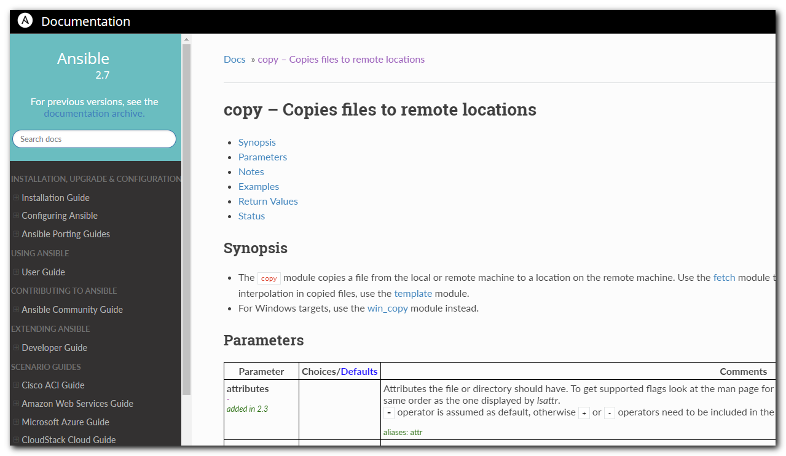
#
# To fix trouble with clamav scenario were made follow.
#
# To test problem task separately, was made follow playbook.
[support@centos 20190320-1619]$ cat roles/clamav/tasks/logs.test.yml
---
- name: "Test for a glitch"
hosts: all
become: yes

tasks:
- name: add logrotate to cron.hourly
copy:
remote_src: /etc/cron.daily/logrotate
dest: /etc/cron.hourly/logrotate
mode: 0755

- name: create clamav log directory
file:
path: "{{ clamav_log_directory_path }}"
state: "directory"
owner: "{{ user_manager_name }}"
group: "{{ group_manager_name }}"
mode: 0755

- name: Remove trash logrotate file from package.
file:
path: "/etc/logrotate.d/clamav-freshclam"
state: absent

- name: Add logrotate configs
template:
src: etc/logrotate.d/{{ item }}.j2
dest: "/etc/logrotate.d/{{ item }}"
with_items:
- clamav.logrotate

[support@centos 20190320-1619]$

[support@centos 20190320-1619]$ ansible-playbook ./roles/clamav/tasks/logs.test.yml -i list_of_hosts --become --extra-vars "ansible_user=bsv ansible_password=$(pass common/linux) ansible_sudo_pass=$(pass common/linux) ansible_ssh_common_args='-oStrictHostKeyChecking=no -oPubkeyAuthentication=no'" -vv | tee -a ./output/$(date +%Y%m%d-%H%M).playbook.txt

# After I understood, what root of this problem, I made follow.
# Was created one file. It was taken from server m1-prt-prod-api01, where clamav already was installed by someone.
#
[support@centos 20190320-1619]$ cat roles/clamav/templates/etc/logrotate.d/logrotate
#!/bin/sh

# Clean non existent log file entries from status file
cd /var/lib/logrotate
test -e status || touch status
head -1 status > status.clean
sed 's/"//g' status | while read logfile date
do
[ -e "$logfile" ] && echo "\"$logfile\" $date"
done >> status.clean
mv status.clean status

test -x /usr/sbin/logrotate || exit 0
/usr/sbin/logrotate /etc/logrotate.conf
[support@centos 20190320-1619]$

#
# Was changed one line from original to "src: roles/clamav/templates/etc/logrotate.d/logrotate"

[support@centos 20190320-1619]$ cat ./roles/clamav/tasks/logs.yml
---
- name: add logrotate to cron.hourly
copy:
src: roles/clamav/templates/etc/logrotate.d/logrotate
dest: /etc/cron.hourly/logrotate
mode: 0755

- name: create clamav log directory
file:
path: "{{ clamav_log_directory_path }}"
state: "directory"
owner: "{{ user_manager_name }}"
group: "{{ group_manager_name }}"
mode: 0755

- name: Remove trash logrotate file from package.
file:
path: "/etc/logrotate.d/clamav-freshclam"
state: absent

- name: Add logrotate configs
template:
src: etc/logrotate.d/{{ item }}.j2
dest: "/etc/logrotate.d/{{ item }}"
with_items:
- clamav.logrotate
[support@centos 20190320-1619]$

#
# After appropriate changes was made, the playbook start working correctly.
#
TASK [graylog-collector-sidecar : Install graylog-sidecar from registry.tcsbank.ru] ******************************************************************************************************************
ok: [vm-pr-atm-zabbix01p]

TASK [graylog-collector-sidecar : Uninstall old sidecar system service] ******************************************************************************************************************************
skipping: [vm-pr-atm-zabbix01p]

TASK [graylog-collector-sidecar : Install new sidecar system service] ********************************************************************************************************************************
skipping: [vm-pr-atm-zabbix01p]

TASK [clamav : Ensure group "clamav_tinkoff" exists] *************************************************************************************************************************************************
ok: [vm-pr-atm-zabbix01p]

TASK [clamav : Ensure user 'clamav_tinkoff' exists] **************************************************************************************************************************************************
ok: [vm-pr-atm-zabbix01p]

TASK [clamav : create clamav config directory] *******************************************************************************************************************************************************
ok: [vm-pr-atm-zabbix01p]

TASK [clamav : Ensure ClamAV packages are installed.] ************************************************************************************************************************************************
ok: [vm-pr-atm-zabbix01p] => (item=clamav)

TASK [clamav : include_tasks] ************************************************************************************************************************************************************************
included: /home/support/work/20190320-1619/roles/clamav/tasks/logs.yml for vm-pr-atm-zabbix01p

TASK [clamav : add logrotate to cron.hourly] *********************************************************************************************************************************************************
changed: [vm-pr-atm-zabbix01p]

TASK [clamav : create clamav log directory] **********************************************************************************************************************************************************
changed: [vm-pr-atm-zabbix01p]

TASK [clamav : Remove trash logrotate file from package.] ********************************************************************************************************************************************
ok: [vm-pr-atm-zabbix01p]

TASK [clamav : Add logrotate configs] ****************************************************************************************************************************************************************
changed: [vm-pr-atm-zabbix01p] => (item=clamav.logrotate)

TASK [clamav : Find freshclam systemd unit filename] *************************************************************************************************************************************************
skipping: [vm-pr-atm-zabbix01p]

TASK [clamav : Disable and stop freshclam_daemon.] ***************************************************************************************************************************************************
skipping: [vm-pr-atm-zabbix01p]

TASK [clamav : Configure freshclam] ******************************************************************************************************************************************************************
changed: [vm-pr-atm-zabbix01p]

TASK [clamav : create clamav virus database directory] ***********************************************************************************************************************************************
changed: [vm-pr-atm-zabbix01p]

TASK [clamav : Remove trash freshclam.conf from package.] ********************************************************************************************************************************************
changed: [vm-pr-atm-zabbix01p]

TASK [clamav : Remove trash clam.d from package.] ****************************************************************************************************************************************************
changed: [vm-pr-atm-zabbix01p]

TASK [clamav : set empty var] ************************************************************************************************************************************************************************
ok: [vm-pr-atm-zabbix01p]

#
# Here is some notes, for what absent file doing. But it’s still not clear for me...
[root@vm-pr-atm-zabbix01p ~]# cat /etc/cron.hourly/logrotate
#!/bin/sh

# Clean non existent log file entries from status file
cd /var/lib/logrotate
test -e status || touch status
head -1 status > status.clean
sed 's/"//g' status | while read logfile date
do
[ -e "$logfile" ] && echo "\"$logfile\" $date"
done >> status.clean
mv status.clean status

test -x /usr/sbin/logrotate || exit 0
/usr/sbin/logrotate /etc/logrotate.conf
[root@vm-pr-atm-zabbix01p ~]# ls /var/lib/logrotate
logrotate.status
[root@vm-pr-atm-zabbix01p ~]# cat /var/lib/logrotate/logrotate.status
logrotate state -- version 2
"/var/log/nginx/error.log" 2019-3-20-3:46:1
"/var/log/yum.log" 2019-1-1-3:39:1
"/var/log/zabbix/zabbix_server.log" 2019-3-18-3:35:1
"/var/log/boot.log" 2019-3-21-3:34:1
"/var/log/httpd/error_log" 2017-11-5-3:42:1
"/var/log/wtmp" 2017-10-17-16:0:0
"/var/log/php-fpm/www-error.log" 2019-3-20-3:46:1
"/var/log/spooler" 2019-3-18-3:35:1
"/var/log/btmp" 2019-3-1-3:47:1
"/var/log/puppet/*log" 2018-10-19-3:0:0
"/var/log/maillog" 2019-3-18-3:35:1
"/var/log/php-fpm/error.log" 2019-3-18-3:35:1
"/var/log/wpa_supplicant.log" 2017-10-17-16:0:0
"/var/log/secure" 2019-3-18-3:35:1
"/var/log/nginx/access.log" 2019-3-21-3:34:1
"/var/log/ppp/connect-errors" 2018-10-19-3:0:0
"/var/log/messages" 2019-3-18-3:35:1
"/var/log/zabbix/zabbix_agentd.log" 2019-3-17-3:36:1
"/var/log/httpd/access_log" 2017-11-5-3:42:1
"/var/log/cron" 2019-3-18-3:35:1
[root@vm-pr-atm-zabbix01p ~]#

# At this moment I tried to understatnd, why in graylog absent data from clamav from target servers.
#
# To compare with a host, where clamav already had been installed.
# On host m1-prt-prod-api01 - clamav and graylog collector were installed not by me.
#
[root@m1-prt-prod-api01 ~]# ls -Alh /etc/clamav/
total 4.0K
-r--r--r-- 1 clamav_tinkoff clamav_tinkoff 222 Sep 21 00:21 freshclam.conf
[root@m1-prt-prod-api01 ~]#

[root@m1-prt-prod-api01 ~]# cat /etc/clamav/freshclam.conf
DatabaseDirectory /var/lib/clamav
UpdateLogFile /var/log/clamav/freshclam.log
LogTime true
LogVerbose true
LogSyslog true
DatabaseOwner clamav_tinkoff
DNSDatabaseInfo clamavdb.tcsbank.ru
DatabaseMirror clamavdb.tcsbank.ru
[root@m1-prt-prod-api01 ~]#

[root@m1-prt-prod-api01 ~]# ls -Alh /etc/graylog/collector-sidecar/
total 16K
-rw-r--r-- 1 root root 36 Sep 21 00:21 collector-id
-rw-r--r-- 1 root root 667 Mar 18 22:05 collector_sidecar.yml
-rw-rw-r-- 1 root root 668 May 30 2018 collector_sidecar.yml.rpmnew
drwxrwxr-x 2 root root 4.0K Oct 2 14:51 generated
[root@m1-prt-prod-api01 ~]#

[root@m1-prt-prod-api01 ~]# cat /etc/graylog/collector-sidecar/collector_sidecar.yml
---
server_url: https://ha-graylog.tcsbank.ru/api/
update_interval: 10
tls_skip_verify: true
send_status: true
list_log_files:
node_id: m1-prt-prod-api01.tcsbank.ru
collector_id: file:/etc/graylog/collector-sidecar/collector-id
log_path: /var/log/graylog/collector-sidecar
log_rotation_time: 86400
log_max_age: 604800
tags:
- m1-prt-prod-api01
backends:
- name: nxlog
enabled: false
binary_path: /usr/bin/nxlog
configuration_path: /etc/graylog/collector-sidecar/generated/nxlog.conf
- name: filebeat
enabled: true
binary_path: /usr/bin/filebeat
configuration_path: /etc/graylog/collector-sidecar/generated/filebeat.yml
You have mail in /var/spool/mail/root
[root@m1-prt-prod-api01 ~]#

[root@m1-prt-prod-api01 ~]# cat /etc/graylog/collector-sidecar/generated/filebeat.yml
filebeat:
prospectors:
- encoding: plain
exclude_files: []
fields:
collector_node_id: m1-prt-prod-api01.tcsbank.ru
gl2_source_collector: 8fea1035-ed45-49d8-b027-f048522453d6
type: log
ignore_older: 0
paths:
- /var/log/clamav/clamd.log
scan_frequency: 10s
tail_files: true
type: log
- encoding: plain
exclude_files: []
fields:
collector_node_id: m1-prt-prod-api01.tcsbank.ru
gl2_source_collector: 8fea1035-ed45-49d8-b027-f048522453d6
type: log
ignore_older: 0
paths:
- /var/log/clamav/freshclam.log
scan_frequency: 10s
tail_files: true
type: log
output:
logstash:
hosts:
- ha-graylog.tcsbank.ru:12628
path:
data: /var/cache/graylog/collector-sidecar/filebeat/data
logs: /var/log/graylog/collector-sidecar
tags:
- m1-prt-prod-api01
- clamav
[root@m1-prt-prod-api01 ~]#

#
# As it was written for cron, the ClamAV will run one time per week in 1.30 AM.
#
[root@m1-prt-prod-api01 ~]# cat /var/spool/cron/root
# Lines below here are managed by Salt, do not edit
# SALT_CRON_IDENTIFIER:python /etc/zabbix/plugins/api_executors_values.py>>/var/log/zabbix/zabbix_sender.log
*/1 * * * * python /etc/zabbix/plugins/api_executors_values.py>>/var/log/zabbix/zabbix_sender.log
# SALT_CRON_IDENTIFIER:python /etc/zabbix/plugins/api_executors_keys.py>>/var/log/zabbix/zabbix_sender.log
*/10 * * * * python /etc/zabbix/plugins/api_executors_keys.py>>/var/log/zabbix/zabbix_sender.log
# SALT_CRON_IDENTIFIER:collect_connections
* * * * * /root/bin/connectlog
# SALT_CRON_IDENTIFIER:check salt-minion
* */2 * * * if ! ps aux | grep salt-minion| grep -v grep; then /sbin/service salt-minion restart && /usr/sbin/service salt-minion restart; fi > /dev/null
#Ansible: ClamAV UPDATE&RUN
30 1 * * 7 sudo /usr/bin/freshclam --config-file=/etc/clamav/freshclam.conf ; sudo /usr/bin/clamscan --database=/var/lib/clamav --exclude-dir='^/sys|^/proc|^/dev|^/bin|^/sbin' --infected --recursive=true --remove=false -l /var/log/clamav/clamav.log --exclude-dir='^/mnt/pfm_images|^/mnt/pfm_images/operations|^/mnt/mortgage|^/mnt/swift_documents|^/mnt/applicant_photo|^/mnt/sme_docs_api|^/mnt/cards_images|^/mnt/insurance|^/mnt/os_dump|^/mnt/recognition|^/mnt/all_pdf|^/mnt/all_pdf2|^/mnt/integration_recognition|^/mnt/application_selfie|^/mnt/client_avatars|^/mnt/integration_recognition2' /
[root@m1-prt-prod-api01 ~]#

[root@m1-prt-prod-api01 ~]# ls /var/log/clamav/
clamav.log clamav.log-20190217.gz clamav.log-20190224.gz clamav.log-20190303.gz clamav.log-20190310.gz clamav.log-20190317 freshclam.log
[root@m1-prt-prod-api01 ~]#

[root@m1-prt-prod-api01 ~]# service collector-sidecar status
Running
[root@m1-prt-prod-api01 ~]#

[root@m1-prt-prod-api01 ~]# ps aux | grep -ie "sideca[r]"
root 9590 0.0 0.0 805828 13716 ? Sl Mar18 1:21 /usr/bin/graylog-collector-sidecar
root 9613 0.0 0.1 697804 24888 ? Sl Mar18 0:25 /usr/bin/filebeat -c /etc/graylog/collector-sidecar/generated/filebeat.yml
[root@m1-prt-prod-api01 ~]#

# As we can see - there is available access from the server to graylog api to get config for collector.
[root@m1-prt-prod-api01 ~]# telnet ha-graylog.tcsbank.ru 443
Trying 10.216.40.170...
Connected to ha-graylog.tcsbank.ru.
Escape character is '^]'.
^]

telnet> quit
Connection closed.
[root@m1-prt-prod-api01 ~]#

...........................................................................

#
# I'd like to fresh contains one clamav's file to test how it will pass to graylog.
#

[root@m1-prt-prod-api01 ~]# /usr/bin/freshclam --config-file=/etc/clamav/freshclam.conf
ERROR: Can't open /var/log/clamav/freshclam.log in append mode (check permissions!).
ERROR: Problem with internal logger (UpdateLogFile = /var/log/clamav/freshclam.log).
[root@m1-prt-prod-api01 ~]#

#
# I've found a way, how to fix this trouble.
# http://blog.files.dp.ua/problema-freshclam-clamav
#
[root@m1-prt-prod-api01 ~]# chmod 777 /var/log/clamav/freshclam.log
You have mail in /var/spool/mail/root
[root@m1-prt-prod-api01 ~]# /usr/bin/freshclam --config-file=/etc/clamav/freshclam.conf
Thu Mar 21 12:26:44 2019 -> *Current working dir is /var/lib/clamav
Thu Mar 21 12:26:44 2019 -> *Max retries == 3
Thu Mar 21 12:26:44 2019 -> ClamAV update process started at Thu Mar 21 12:26:44 2019
Thu Mar 21 12:26:44 2019 -> *Using IPv6 aware code
Thu Mar 21 12:26:44 2019 -> *Querying clamavdb.tcsbank.ru
Thu Mar 21 12:26:44 2019 -> ^Can't query clamavdb.tcsbank.ru
Thu Mar 21 12:26:44 2019 -> ^Invalid DNS reply. Falling back to HTTP mode.
Thu Mar 21 12:26:44 2019 -> *If-Modified-Since: Wed, 07 Jun 2017 21:38:10 GMT
Thu Mar 21 12:26:44 2019 -> Reading CVD header (main.cvd): Thu Mar 21 12:26:44 2019 -> *Connected to clamavdb.tcsbank.ru (IP: 10.216.42.6).
Thu Mar 21 12:26:44 2019 -> *Trying to retrieve CVD header of http://clamavdb.tcsbank.ru/main.cvd
Thu Mar 21 12:26:44 2019 -> OK
Thu Mar 21 12:26:44 2019 -> main.cvd is up to date (version: 58, sigs: 4566249, f-level: 60, builder: sigmgr)
Thu Mar 21 12:26:44 2019 -> *If-Modified-Since: Tue, 10 Jul 2018 20:52:06 GMT
Thu Mar 21 12:26:44 2019 -> Reading CVD header (daily.cvd): Thu Mar 21 12:26:44 2019 -> *Connected to clamavdb.tcsbank.ru (IP: 10.216.42.6).
Thu Mar 21 12:26:44 2019 -> *Trying to retrieve CVD header of http://clamavdb.tcsbank.ru/daily.cvd
Thu Mar 21 12:26:44 2019 -> OK
Thu Mar 21 12:26:45 2019 -> *Retrieving http://clamavdb.tcsbank.ru/daily-24742.cdiff
Thu Mar 21 12:26:45 2019 -> *Trying to download http://clamavdb.tcsbank.ru/daily-24742.cdiff (IP: 10.216.42.6)
Thu Mar 21 12:26:45 2019 -> ^getfile: daily-24742.cdiff not found on clamavdb.tcsbank.ru (IP: 10.216.42.6)
Thu Mar 21 12:26:45 2019 -> ^getpatch: Can't download daily-24742.cdiff from clamavdb.tcsbank.ru
Thu Mar 21 12:26:45 2019 -> *Retrieving http://clamavdb.tcsbank.ru/daily-24742.cdiff
Thu Mar 21 12:26:45 2019 -> *Ignoring mirror 10.216.42.6 (due to previous errors)
Thu Mar 21 12:26:45 2019 -> ^getpatch: Can't download daily-24742.cdiff from clamavdb.tcsbank.ru
Thu Mar 21 12:26:45 2019 -> *Retrieving http://clamavdb.tcsbank.ru/daily-24742.cdiff
Thu Mar 21 12:26:45 2019 -> *Ignoring mirror 10.216.42.6 (due to previous errors)
Thu Mar 21 12:26:45 2019 -> ^getpatch: Can't download daily-24742.cdiff from clamavdb.tcsbank.ru
Thu Mar 21 12:26:45 2019 -> ^Incremental update failed, trying to download daily.cvd
Thu Mar 21 12:26:45 2019 -> *Whitelisting short-term blacklisted mirrors
Thu Mar 21 12:26:45 2019 -> *Retrieving http://clamavdb.tcsbank.ru/daily.cvd
Thu Mar 21 12:26:45 2019 -> *Trying to download http://clamavdb.tcsbank.ru/daily.cvd (IP: 10.216.42.6)
Thu Mar 21 12:26:45 2019 -> Downloading daily.cvd [100%]
Thu Mar 21 12:26:47 2019 -> *Loading signatures from daily.cvd
Thu Mar 21 12:27:10 2019 -> *Properly loaded 1526391 signatures from new daily.cvd
Thu Mar 21 12:27:11 2019 -> daily.cvd updated (version: 25395, sigs: 1526391, f-level: 63, builder: raynman)
Thu Mar 21 12:27:11 2019 -> *If-Modified-Since: Mon, 09 Jul 2018 23:36:55 GMT
Thu Mar 21 12:27:11 2019 -> Reading CVD header (bytecode.cvd): Thu Mar 21 12:27:11 2019 -> *Connected to clamavdb.tcsbank.ru (IP: 10.216.42.6).
Thu Mar 21 12:27:11 2019 -> *Trying to retrieve CVD header of http://clamavdb.tcsbank.ru/bytecode.cvd
Thu Mar 21 12:27:11 2019 -> OK
Thu Mar 21 12:27:11 2019 -> *Retrieving http://clamavdb.tcsbank.ru/bytecode-325.cdiff
Thu Mar 21 12:27:11 2019 -> *Trying to download http://clamavdb.tcsbank.ru/bytecode-325.cdiff (IP: 10.216.42.6)
Thu Mar 21 12:27:11 2019 -> ^getfile: bytecode-325.cdiff not found on clamavdb.tcsbank.ru (IP: 10.216.42.6)
Thu Mar 21 12:27:11 2019 -> ^getpatch: Can't download bytecode-325.cdiff from clamavdb.tcsbank.ru
Thu Mar 21 12:27:11 2019 -> *Retrieving http://clamavdb.tcsbank.ru/bytecode-325.cdiff
Thu Mar 21 12:27:11 2019 -> *Ignoring mirror 10.216.42.6 (due to previous errors)
Thu Mar 21 12:27:11 2019 -> ^getpatch: Can't download bytecode-325.cdiff from clamavdb.tcsbank.ru
Thu Mar 21 12:27:11 2019 -> *Retrieving http://clamavdb.tcsbank.ru/bytecode-325.cdiff
Thu Mar 21 12:27:11 2019 -> *Ignoring mirror 10.216.42.6 (due to previous errors)
Thu Mar 21 12:27:11 2019 -> ^getpatch: Can't download bytecode-325.cdiff from clamavdb.tcsbank.ru
Thu Mar 21 12:27:11 2019 -> ^Incremental update failed, trying to download bytecode.cvd
Thu Mar 21 12:27:11 2019 -> *Whitelisting short-term blacklisted mirrors
Thu Mar 21 12:27:11 2019 -> *Retrieving http://clamavdb.tcsbank.ru/bytecode.cvd
Thu Mar 21 12:27:11 2019 -> *Trying to download http://clamavdb.tcsbank.ru/bytecode.cvd (IP: 10.216.42.6)
Thu Mar 21 12:27:11 2019 -> Downloading bytecode.cvd [100%]
Thu Mar 21 12:27:11 2019 -> *Loading signatures from bytecode.cvd
Thu Mar 21 12:27:11 2019 -> *Properly loaded 94 signatures from new bytecode.cvd
Thu Mar 21 12:27:11 2019 -> bytecode.cvd updated (version: 328, sigs: 94, f-level: 63, builder: neo)
Thu Mar 21 12:27:15 2019 -> Database updated (6092734 signatures) from clamavdb.tcsbank.ru (IP: 10.216.42.6)
[root@m1-prt-prod-api01 ~]#

...........................................................................

[root@vm-pr-atm-zabbix01p ~]# cat /var/spool/cron/root
#Ansible: ClamAV UPDATE&RUN
30 1 * * 7 sudo /usr/bin/freshclam --config-file=/etc/clamav/freshclam.conf ; sudo /usr/bin/clamscan --database=/var/lib/clamav --exclude-dir='^/sys|^/proc|^/dev|^/bin|^/sbin' --infected --recursive=true --remove=false -l /var/log/clamav/clamav.log --exclude-dir='[|]' /
[root@vm-pr-atm-zabbix01p ~]# /usr/bin/freshclam --config-file=/etc/clamav/freshclam.conf
Thu Mar 21 17:20:50 2019 -> *Current working dir is /var/lib/clamav
Thu Mar 21 17:20:50 2019 -> ClamAV update process started at Thu Mar 21 17:20:50 2019
Thu Mar 21 17:20:50 2019 -> *Using IPv6 aware code
Thu Mar 21 17:20:50 2019 -> *Max retries == 3
Thu Mar 21 17:20:50 2019 -> *Querying clamavdb.tcsbank.ru
Thu Mar 21 17:20:50 2019 -> ^Can't query clamavdb.tcsbank.ru
Thu Mar 21 17:20:50 2019 -> ^Invalid DNS reply. Falling back to HTTP mode.
Thu Mar 21 17:20:50 2019 -> *Retrieving http://clamavdb.tcsbank.ru/main.cvd
Thu Mar 21 17:20:50 2019 -> *Trying to download http://clamavdb.tcsbank.ru/main.cvd (IP: 10.216.42.6)
Thu Mar 21 17:20:51 2019 -> Downloading main.cvd [100%]
Thu Mar 21 17:20:53 2019 -> *Loading signatures from main.cvd
Thu Mar 21 17:20:59 2019 -> *Properly loaded 4566249 signatures from new main.cvd
Thu Mar 21 17:20:59 2019 -> main.cvd updated (version: 58, sigs: 4566249, f-level: 60, builder: sigmgr)
Thu Mar 21 17:20:59 2019 -> *Retrieving http://clamavdb.tcsbank.ru/daily.cvd
Thu Mar 21 17:20:59 2019 -> *Trying to download http://clamavdb.tcsbank.ru/daily.cvd (IP: 10.216.42.6)
Thu Mar 21 17:21:00 2019 -> Downloading daily.cvd [100%]
Thu Mar 21 17:21:01 2019 -> *Loading signatures from daily.cvd
Thu Mar 21 17:21:17 2019 -> *Properly loaded 1526391 signatures from new daily.cvd
Thu Mar 21 17:21:17 2019 -> daily.cvd updated (version: 25395, sigs: 1526391, f-level: 63, builder: raynman)
Thu Mar 21 17:21:17 2019 -> *Retrieving http://clamavdb.tcsbank.ru/bytecode.cvd
Thu Mar 21 17:21:17 2019 -> *Trying to download http://clamavdb.tcsbank.ru/bytecode.cvd (IP: 10.216.42.6)
Thu Mar 21 17:21:17 2019 -> Downloading bytecode.cvd [100%]
Thu Mar 21 17:21:17 2019 -> *Loading signatures from bytecode.cvd
Thu Mar 21 17:21:17 2019 -> *Properly loaded 94 signatures from new bytecode.cvd
Thu Mar 21 17:21:17 2019 -> bytecode.cvd updated (version: 328, sigs: 94, f-level: 63, builder: neo)
Thu Mar 21 17:21:21 2019 -> Database updated (6092734 signatures) from clamavdb.tcsbank.ru (IP: 10.216.42.6)
[root@vm-pr-atm-zabbix01p ~]#

#
# There is no access to graylog api (not available to get filebeat config).
[root@vm-pr-atm-zabbix01p ~]# telnet ha-graylog.tcsbank.ru 443
Trying 10.216.40.170...

[root@vm-pr-atm-zabbix01p ~]#

[root@vm-pr-atm-zabbix01p ~]# cat /etc/graylog/collector-sidecar/generated/filebeat.yml
cat: /etc/graylog/collector-sidecar/generated/filebeat.yml: No such file or directory
[root@vm-pr-atm-zabbix01p ~]#

...........................................................................

#
# On this server access to graylog api exists. And filebeat.yml config was created.

[root@ds-prt-prod-api11 ~]# cat /etc/graylog/collector-sidecar/collector_sidecar.yml
---
server_url: https://ha-graylog.tcsbank.ru/api/
update_interval: 10
tls_skip_verify: true
send_status: true
list_log_files:
node_id: ds-prt-prod-api11.tcsbank.ru
collector_id: file:/etc/graylog/collector-sidecar/collector-id
log_path: /var/log/graylog/collector-sidecar
log_rotation_time: 86400
log_max_age: 604800
tags:
- ds-prt-prod-api11
backends:
- name: nxlog
enabled: false
binary_path: /usr/bin/nxlog
configuration_path: /etc/graylog/collector-sidecar/generated/nxlog.conf
- name: filebeat
enabled: true
binary_path: /usr/bin/filebeat
configuration_path: /etc/graylog/collector-sidecar/generated/filebeat.yml
[root@ds-prt-prod-api11 ~]#

[root@ds-prt-prod-api11 ~]# telnet ha-graylog.tcsbank.ru 443
Trying 10.216.40.170...
Connected to ha-graylog.tcsbank.ru.
Escape character is '^]'.
^]

telnet> quit
Connection closed.
[root@ds-prt-prod-api11 ~]#

#
# But unavailable to send logs to appropriate port.
#
[root@ds-prt-prod-api11 ~]# cat /etc/graylog/collector-sidecar/generated/filebeat.yml
filebeat:
prospectors:
- encoding: plain
exclude_files: []
fields:
collector_node_id: ds-prt-prod-api11.tcsbank.ru
gl2_source_collector: ed83e9a6-c9ba-46fb-a30a-173cc2720b71
type: log
ignore_older: 0
paths:
- /var/log/clamav/clamd.log
scan_frequency: 10s
tail_files: true
type: log
- encoding: plain
exclude_files: []
fields:
collector_node_id: ds-prt-prod-api11.tcsbank.ru
gl2_source_collector: ed83e9a6-c9ba-46fb-a30a-173cc2720b71
type: log
ignore_older: 0
paths:
- /var/log/clamav/freshclam.log
scan_frequency: 10s
tail_files: true
type: log
output:
logstash:
hosts:
- ha-graylog.tcsbank.ru:12628
path:
data: /var/cache/graylog/collector-sidecar/filebeat/data
logs: /var/log/graylog/collector-sidecar
tags:
- clamav
[root@ds-prt-prod-api11 ~]#

[root@ds-prt-prod-api11 ~]# telnet ha-graylog.tcsbank.ru 12628
Trying 10.216.40.170...
telnet: connect to address 10.216.40.170: Connection refused
[root@ds-prt-prod-api11 ~]#

...........................................................................

#
# On servers with systemctl utility (Systemd start scripts) RedHat 7.x, CentOS 7.x.
# Doesn't work properly start for collector-sidecar.
#

https://gitlab.tcsbank.ru/jet/ansible/blob/master/roles/graylog-collector/handlers/main.yml
---
- name: restart collector_sidecar
service:
name: "{{ sidecar_service }}"
state: restarted
enabled: yes

https://gitlab.tcsbank.ru/jet/ansible/blob/master/roles/graylog-collector/tasks/main.yml
- name: activate collector_sidecar
shell: graylog-collector-sidecar -service install && systemctl daemon-reload
when: install_latest.changed or install_specific.changed

root@m1-pr-atmapi04p ~$ graylog-collector-sidecar -service install && systemctl daemon-reload

root@m1-pr-atmapi04p ~$ systemctl status collector-sidecar.service
? collector-sidecar.service - Wrapper service for Graylog controlled collector
Loaded: loaded (/etc/systemd/system/collector-sidecar.service; enabled; vendor preset: disabled)
Active: inactive (dead)
root@m1-pr-atmapi04p ~$

root@m1-pr-atmapi04p ~$ systemctl start collector-sidecar.service
root@m1-pr-atmapi04p ~$ systemctl enable collector-sidecar.service
root@m1-pr-atmapi04p ~$ systemctl status collector-sidecar.service
? collector-sidecar.service - Wrapper service for Graylog controlled collector
Loaded: loaded (/etc/systemd/system/collector-sidecar.service; enabled; vendor preset: disabled)
Active: active (running) since Thu 2019-03-21 18:39:01 MSK; 11s ago
Main PID: 3999 (graylog-collect)
CGroup: /system.slice/collector-sidecar.service
L-3999 /usr/bin/graylog-collector-sidecar

Mar 21 18:39:02 m1-pr-atmapi04p.tcsbank.ru graylog-collector-sidecar[3999]: time="2019-03-21T18:39:02+03:00" level=info msg="[filebeat] Stopping"
Mar 21 18:39:04 m1-pr-atmapi04p.tcsbank.ru graylog-collector-sidecar[3999]: time="2019-03-21T18:39:04+03:00" level=info msg="[filebeat] Starting (exec driver)"
Mar 21 18:39:05 m1-pr-atmapi04p.tcsbank.ru graylog-collector-sidecar[3999]: time="2019-03-21T18:39:05+03:00" level=error msg="[filebeat] Backend finished unexpectedly, trying to restart 2/3."
Mar 21 18:39:05 m1-pr-atmapi04p.tcsbank.ru graylog-collector-sidecar[3999]: time="2019-03-21T18:39:05+03:00" level=info msg="[filebeat] Stopping"
Mar 21 18:39:07 m1-pr-atmapi04p.tcsbank.ru graylog-collector-sidecar[3999]: time="2019-03-21T18:39:07+03:00" level=info msg="[filebeat] Starting (exec driver)"
Mar 21 18:39:08 m1-pr-atmapi04p.tcsbank.ru graylog-collector-sidecar[3999]: time="2019-03-21T18:39:08+03:00" level=error msg="[filebeat] Backend finished unexpectedly, trying to restart 3/3."
Mar 21 18:39:08 m1-pr-atmapi04p.tcsbank.ru graylog-collector-sidecar[3999]: time="2019-03-21T18:39:08+03:00" level=info msg="[filebeat] Stopping"
Mar 21 18:39:10 m1-pr-atmapi04p.tcsbank.ru graylog-collector-sidecar[3999]: time="2019-03-21T18:39:10+03:00" level=info msg="[filebeat] Starting (exec driver)"
Mar 21 18:39:11 m1-pr-atmapi04p.tcsbank.ru graylog-collector-sidecar[3999]: time="2019-03-21T18:39:11+03:00" level=error msg="[filebeat] Unable to start collector after 3 tries, giving up!"
Mar 21 18:39:11 m1-pr-atmapi04p.tcsbank.ru graylog-collector-sidecar[3999]: time="2019-03-21T18:39:11+03:00" level=info msg="[RequestConfiguration] No configuration found for configured tags!"
Hint: Some lines were ellipsized, use -l to show in full.
root@m1-pr-atmapi04p ~$

#
# Here is an example of task in tufin to get access from servers to graylog.
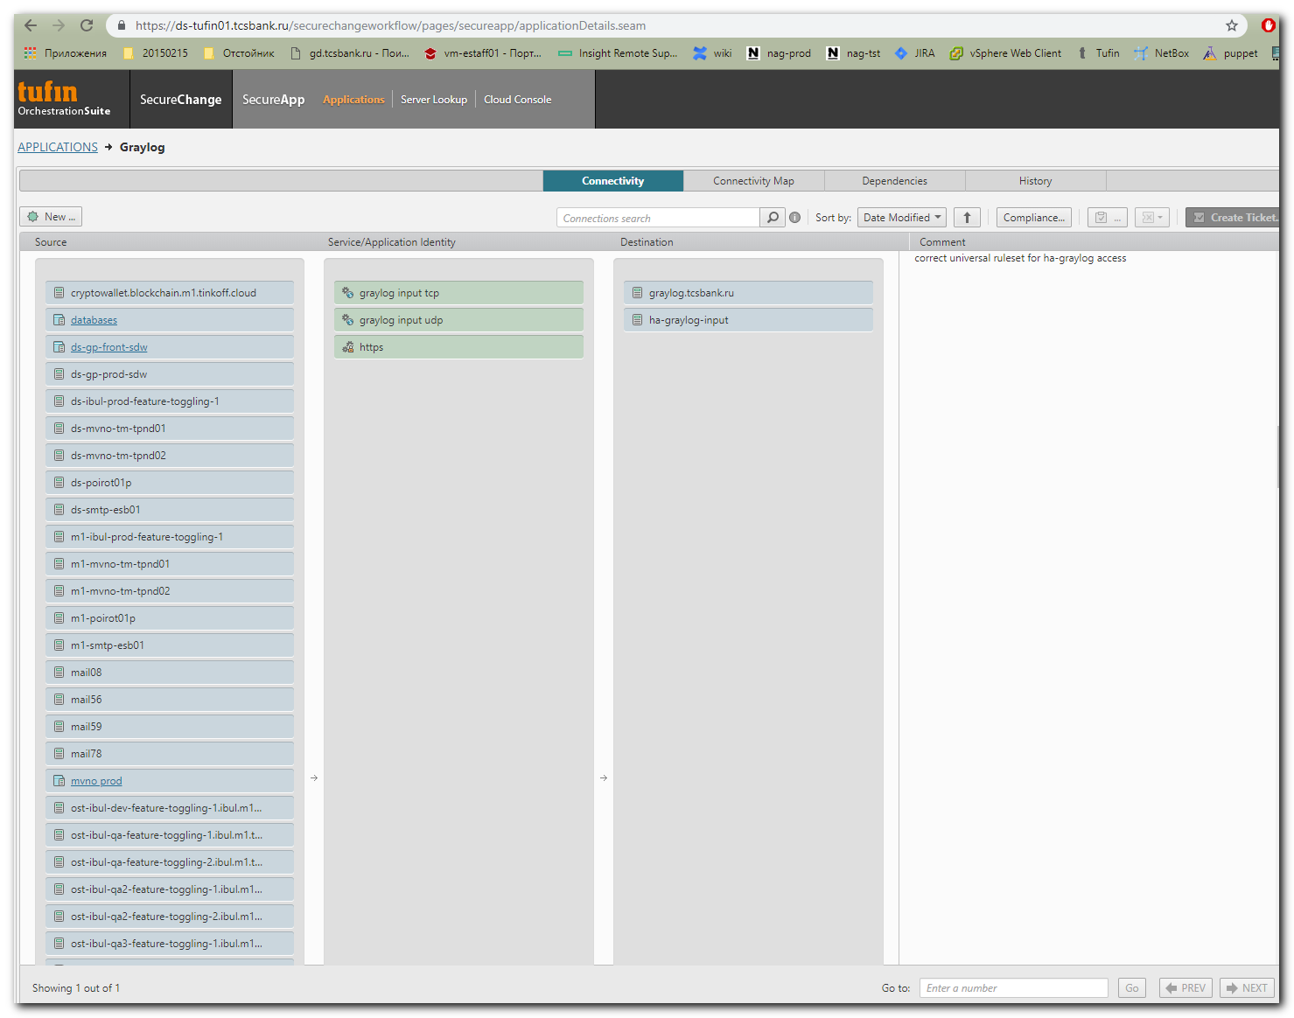

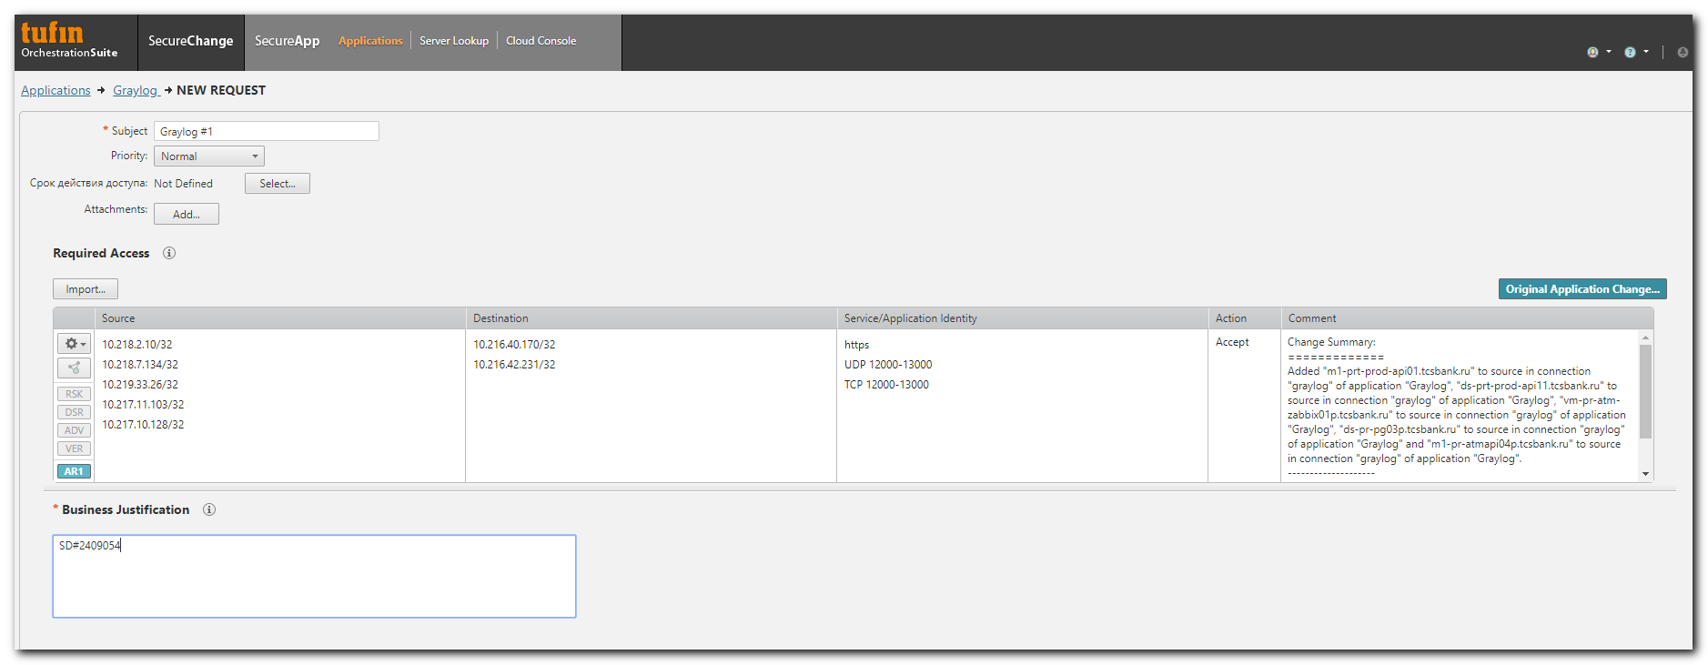

# On server, where clamav was installed before, I’ve found collector.
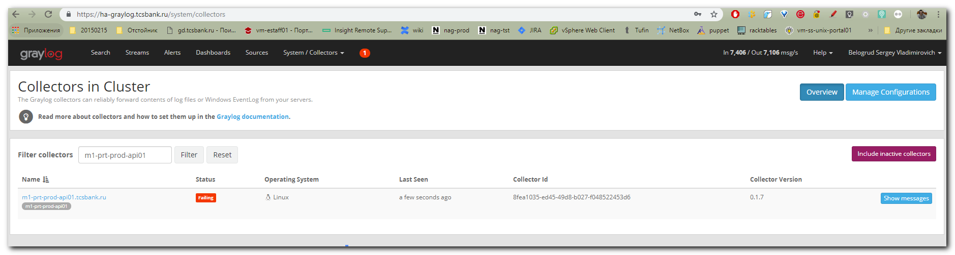
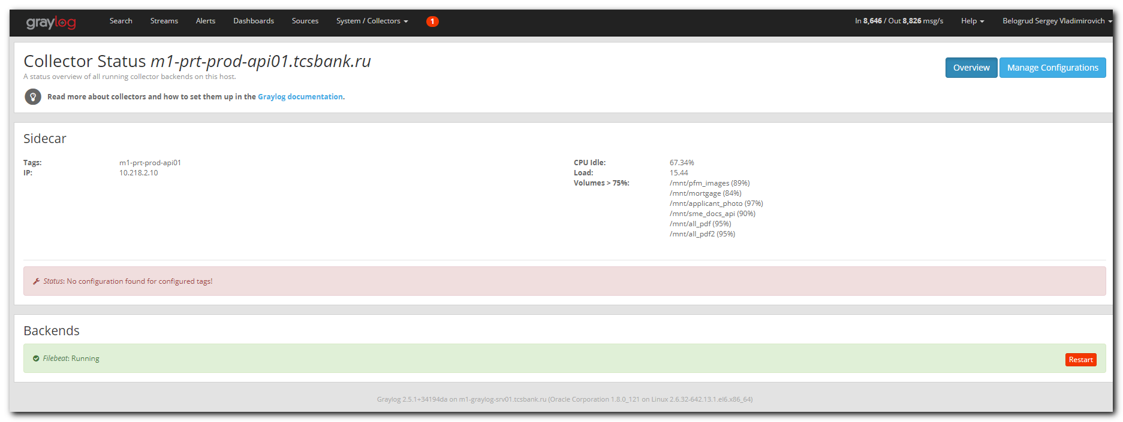
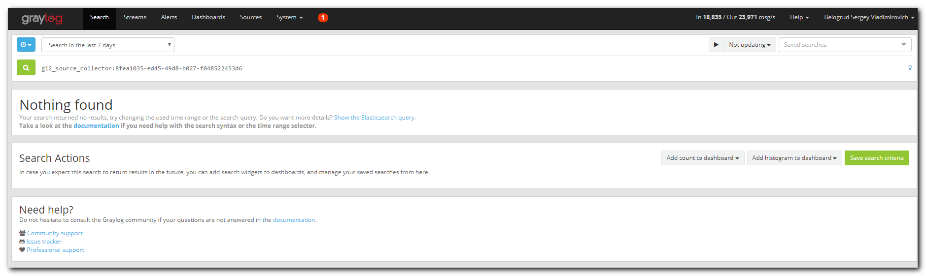
# To see config for collector for tag “clamav”.
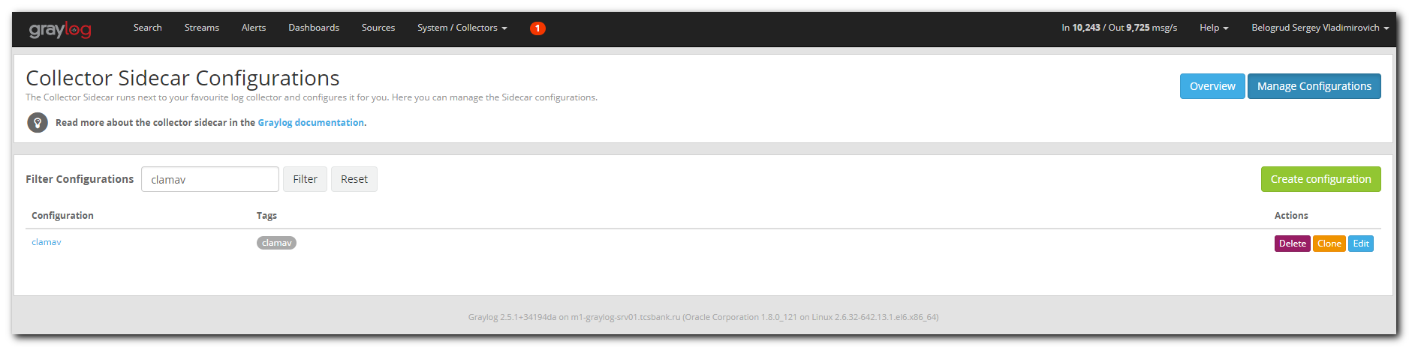
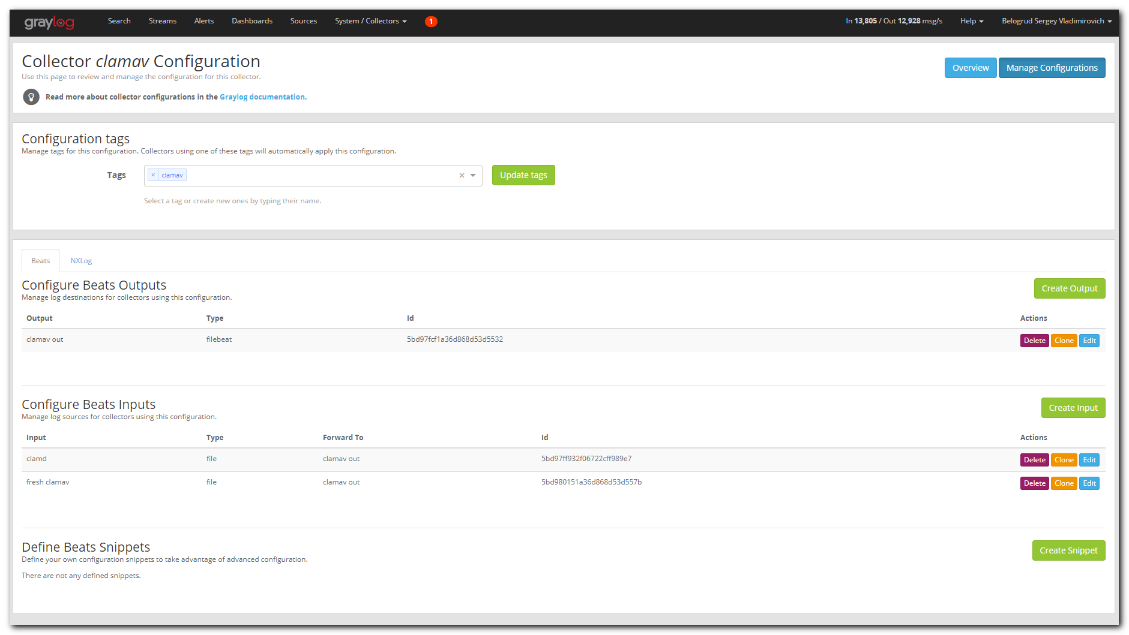
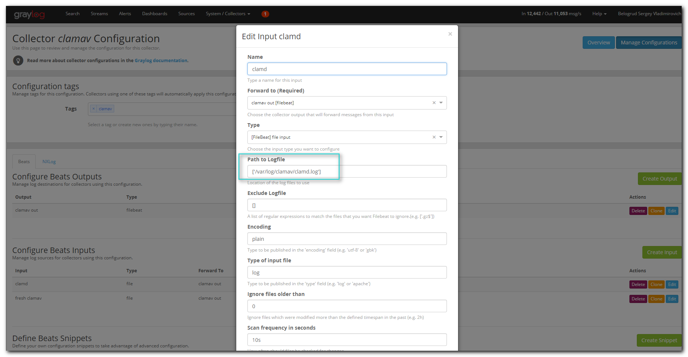
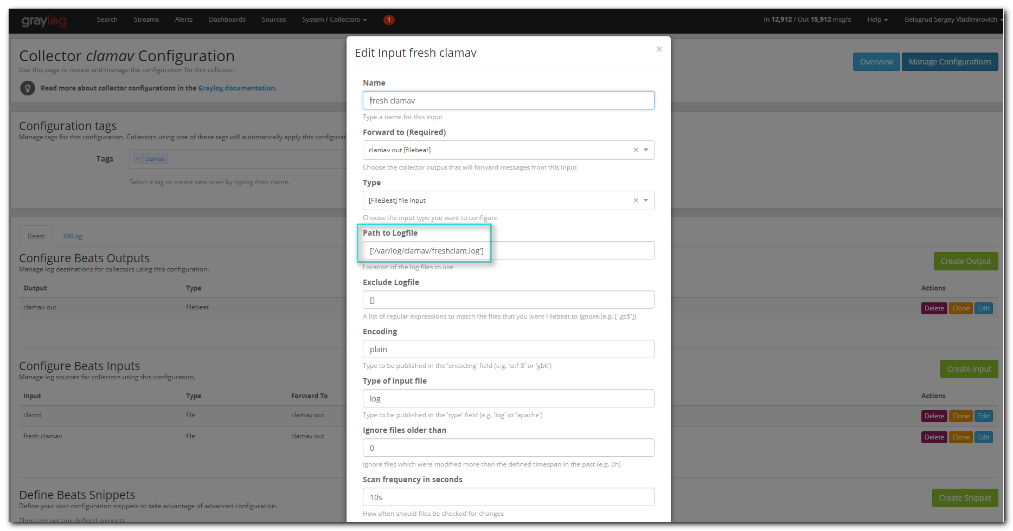

#
# After access from the server to graylog was given.
#
[root@m1-prt-prod-api01 ~]# telnet ha-graylog.tcsbank.ru 12628
Trying 10.216.40.170...
Connected to ha-graylog.tcsbank.ru.
Escape character is '^]'.
^]

telnet> quit
Connection closed.
[root@m1-prt-prod-api01 ~]#

# But in graylog nothing changed.
#
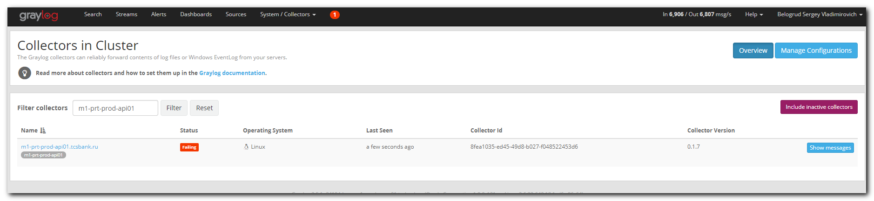

# I’ve pressed the button on web interface. But nothing was happened.
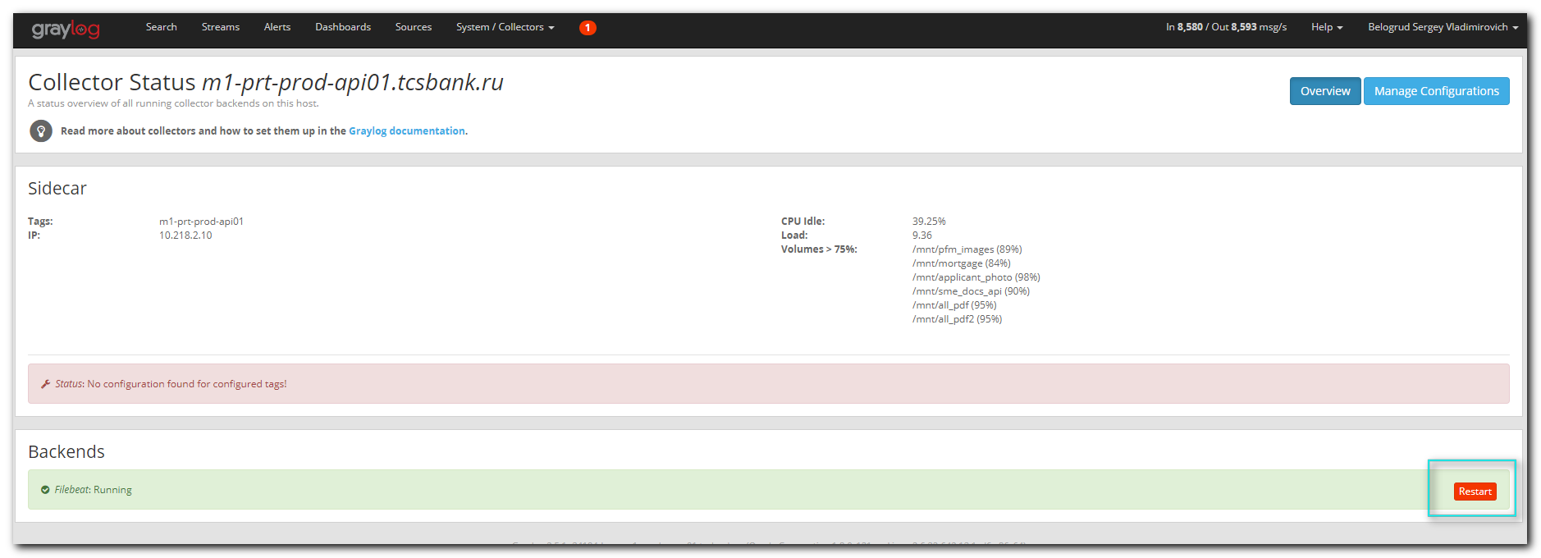

[root@m1-prt-prod-api01 ~]# service collector-sidecar stop
Stopping collector-sidecar...
Stopped
[root@m1-prt-prod-api01 ~]# service collector-sidecar start
Starting collector-sidecar
[root@m1-prt-prod-api01 ~]#

# On several seconds after servcie restarted, I’ve seen follow changes.
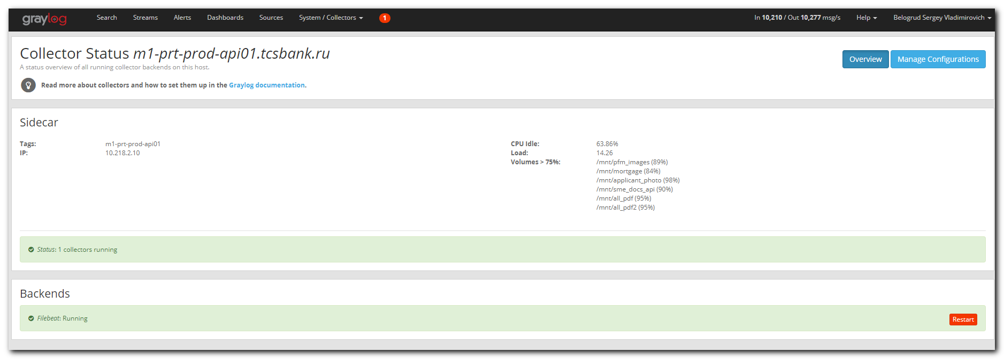
# But then, the page returned to its previous state.

# For server, were clamav was installed by me - no collectors found.
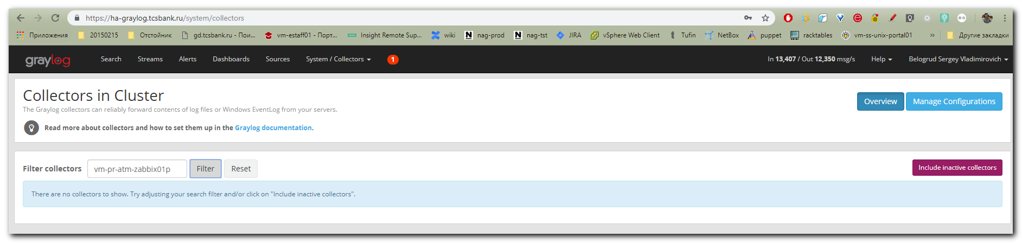
[root@vm-pr-atm-zabbix01p ~]# systemctl status collector-sidecar.service
Unit collector-sidecar.service could not be found.
[root@vm-pr-atm-zabbix01p ~]# cat /etc/redhat-release
CentOS Linux release 7.4.1708 (Core)
[root@vm-pr-atm-zabbix01p ~]#

[root@vm-pr-atm-zabbix01p ~]# graylog-collector-sidecar -service install
[root@vm-pr-atm-zabbix01p ~]# systemctl status collector-sidecar.service
● collector-sidecar.service - Wrapper service for Graylog controlled collector
Loaded: loaded (/etc/systemd/system/collector-sidecar.service; enabled; vendor preset: disabled)
Active: inactive (dead)
[root@vm-pr-atm-zabbix01p ~]# systemctl start collector-sidecar.service
[root@vm-pr-atm-zabbix01p ~]# systemctl status collector-sidecar.service
● collector-sidecar.service - Wrapper service for Graylog controlled collector
Loaded: loaded (/etc/systemd/system/collector-sidecar.service; enabled; vendor preset: disabled)
Active: active (running) since Fri 2019-03-22 18:53:06 MSK; 5s ago
Main PID: 14329 (graylog-collect)
Memory: 28.7M
CGroup: /system.slice/collector-sidecar.service
└─14329 /usr/bin/graylog-collector-sidecar

Mar 22 18:53:06 vm-pr-atm-zabbix01p.tcsbank.ru graylog-collector-sidecar[14329]: time="2019-03-22T18:53:06+03:00" level=info msg="Using collector-id: 4be166f9-94db-4568-887b-676a8e62df66"
Mar 22 18:53:06 vm-pr-atm-zabbix01p.tcsbank.ru graylog-collector-sidecar[14329]: time="2019-03-22T18:53:06+03:00" level=info msg="Fetching configurations tagged by: [vm-pr-atm-zabbix01p]"
Mar 22 18:53:06 vm-pr-atm-zabbix01p.tcsbank.ru graylog-collector-sidecar[14329]: time="2019-03-22T18:53:06+03:00" level=error msg="No cache directory was configured. Using default:...-sidecar"
Mar 22 18:53:06 vm-pr-atm-zabbix01p.tcsbank.ru graylog-collector-sidecar[14329]: time="2019-03-22T18:53:06+03:00" level=info msg="Starting signal distributor"
Mar 22 18:53:06 vm-pr-atm-zabbix01p.tcsbank.ru graylog-collector-sidecar[14329]: time="2019-03-22T18:53:06+03:00" level=info msg="[filebeat] Starting (exec driver)"
Mar 22 18:53:07 vm-pr-atm-zabbix01p.tcsbank.ru graylog-collector-sidecar[14329]: time="2019-03-22T18:53:07+03:00" level=error msg="[filebeat] Backend finished unexpectedly, trying ...art 1/3."
Mar 22 18:53:07 vm-pr-atm-zabbix01p.tcsbank.ru graylog-collector-sidecar[14329]: time="2019-03-22T18:53:07+03:00" level=info msg="[filebeat] Stopping"
Mar 22 18:53:09 vm-pr-atm-zabbix01p.tcsbank.ru graylog-collector-sidecar[14329]: time="2019-03-22T18:53:09+03:00" level=info msg="[filebeat] Starting (exec driver)"
Mar 22 18:53:10 vm-pr-atm-zabbix01p.tcsbank.ru graylog-collector-sidecar[14329]: time="2019-03-22T18:53:10+03:00" level=error msg="[filebeat] Backend finished unexpectedly, trying ...art 2/3."
Mar 22 18:53:10 vm-pr-atm-zabbix01p.tcsbank.ru graylog-collector-sidecar[14329]: time="2019-03-22T18:53:10+03:00" level=info msg="[filebeat] Stopping"
Hint: Some lines were ellipsized, use -l to show in full.
[root@vm-pr-atm-zabbix01p ~]#

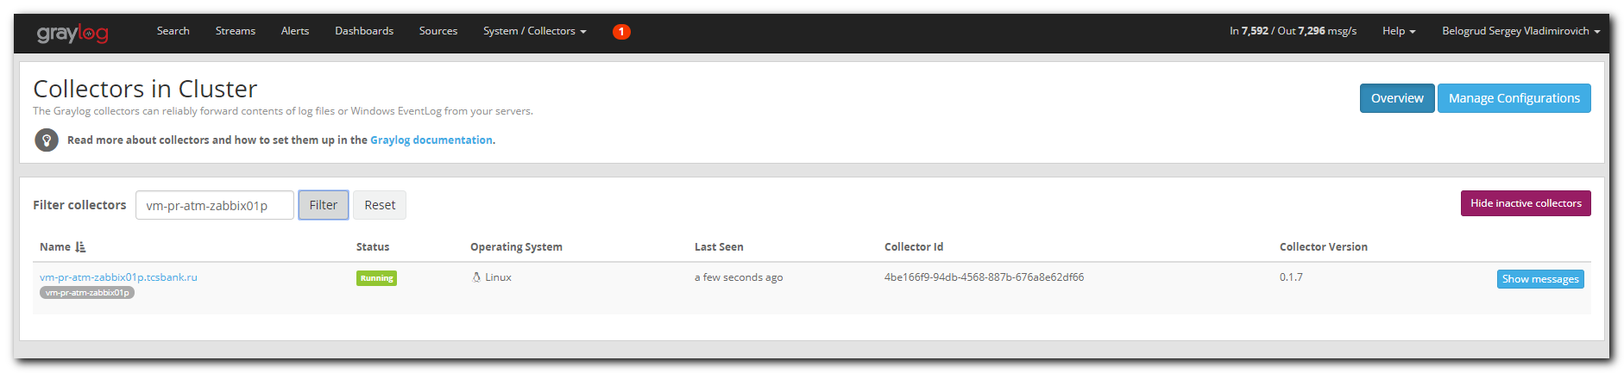
#
# But after several seconds if press “F5” to update the page we will see follow....
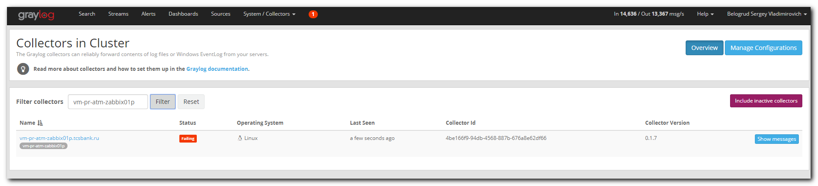

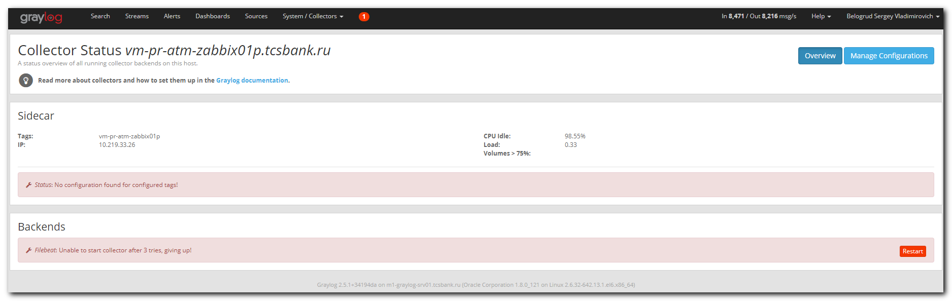

[root@vm-pr-atm-zabbix01p ~]# less /var/log/graylog/collector-sidecar/collector_sidecar.log
time="2019-03-22T18:53:06+03:00" level=info msg="Starting signal distributor"
time="2019-03-22T18:53:06+03:00" level=info msg="[filebeat] Starting (exec driver)"
...
time="2019-03-22T18:53:13+03:00" level=error msg="[filebeat] Backend finished unexpectedly, trying to restart 3/3."
time="2019-03-22T18:53:13+03:00" level=info msg="[filebeat] Stopping"
time="2019-03-22T18:53:15+03:00" level=info msg="[filebeat] Starting (exec driver)"
time="2019-03-22T18:53:16+03:00" level=error msg="[filebeat] Unable to start collector after 3 tries, giving up!"
time="2019-03-22T18:53:16+03:00" level=info msg="[RequestConfiguration] No configuration found for configured tags!"
time="2019-03-22T18:53:26+03:00" level=info msg="[RequestConfiguration] No configuration found for configured tags!"
time="2019-03-22T18:53:36+03:00" level=info msg="[RequestConfiguration] No configuration found for configured tags!"
time="2019-03-22T18:53:46+03:00" level=info msg="[RequestConfiguration] No configuration found for configured tags!"
...

[root@vm-pr-atm-zabbix01p ~]# less /var/log/graylog/collector-sidecar/filebeat_stderr.log
Exiting: error loading config file: stat /etc/graylog/collector-sidecar/generated/filebeat.yml: no such file or directory
Exiting: error loading config file: stat /etc/graylog/collector-sidecar/generated/filebeat.yml: no such file or directory
Exiting: error loading config file: stat /etc/graylog/collector-sidecar/generated/filebeat.yml: no such file or directory
Exiting: error loading config file: stat /etc/graylog/collector-sidecar/generated/filebeat.yml: no such file or directory

[root@vm-pr-atm-zabbix01p ~]# ls -Alh /etc/graylog/collector-sidecar/
total 12K
-rw-r--r-- 1 root root 36 Mar 22 18:53 collector-id
-rw-r--r-- 1 root root 671 Mar 21 12:33 collector_sidecar.yml
-rw-rw-r-- 1 root root 668 Oct 2 14:51 collector_sidecar.yml.rpmnew
drwxrwxr-x 2 root root 6 Oct 2 14:51 generated
[root@vm-pr-atm-zabbix01p ~]# ls -Alh /etc/graylog/collector-sidecar/generated/
total 0
[root@vm-pr-atm-zabbix01p ~]#

#
# Only after I’ve added one line with tag “clamav” the situation was changed.
[root@vm-pr-atm-zabbix01p ~]# cat /etc/graylog/collector-sidecar/collector_sidecar.yml
---
server_url: https://ha-graylog.tcsbank.ru/api/
update_interval: 10
tls_skip_verify: true
send_status: true
list_log_files:
node_id: vm-pr-atm-zabbix01p.tcsbank.ru
collector_id: file:/etc/graylog/collector-sidecar/collector-id
log_path: /var/log/graylog/collector-sidecar
log_rotation_time: 86400
log_max_age: 604800
tags:
- vm-pr-atm-zabbix01p
backends:
- name: nxlog
enabled: false
binary_path: /usr/bin/nxlog
configuration_path: /etc/graylog/collector-sidecar/generated/nxlog.conf
- name: filebeat
enabled: true
binary_path: /usr/bin/filebeat
configuration_path: /etc/graylog/collector-sidecar/generated/filebeat.yml
[root@vm-pr-atm-zabbix01p ~]# systemctl stop collector-sidecar.service
[root@vm-pr-atm-zabbix01p ~]# vim /etc/graylog/collector-sidecar/collector_sidecar.yml
[root@vm-pr-atm-zabbix01p ~]# cat /etc/graylog/collector-sidecar/collector_sidecar.yml
---
server_url: https://ha-graylog.tcsbank.ru/api/
update_interval: 10
tls_skip_verify: true
send_status: true
list_log_files:
node_id: vm-pr-atm-zabbix01p.tcsbank.ru
collector_id: file:/etc/graylog/collector-sidecar/collector-id
log_path: /var/log/graylog/collector-sidecar
log_rotation_time: 86400
log_max_age: 604800
tags:
- vm-pr-atm-zabbix01p
- clamav
backends:
- name: nxlog
enabled: false
binary_path: /usr/bin/nxlog
configuration_path: /etc/graylog/collector-sidecar/generated/nxlog.conf
- name: filebeat
enabled: true
binary_path: /usr/bin/filebeat
configuration_path: /etc/graylog/collector-sidecar/generated/filebeat.yml
[root@vm-pr-atm-zabbix01p ~]#

[root@vm-pr-atm-zabbix01p ~]# systemctl start collector-sidecar.service
[root@vm-pr-atm-zabbix01p ~]#

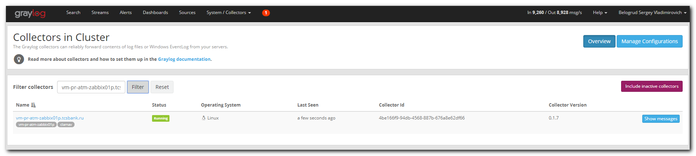
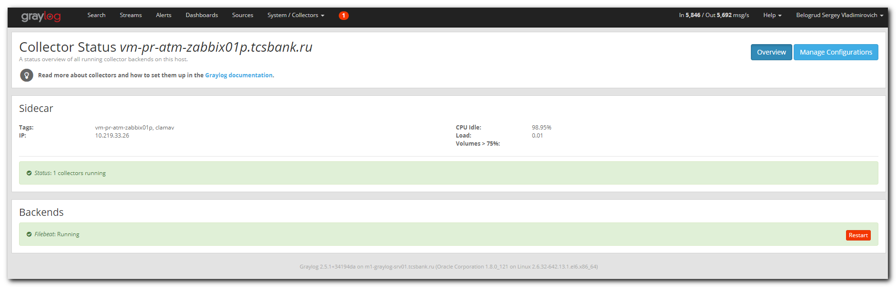

[root@vm-pr-atm-zabbix01p ~]# ls -Alh /etc/graylog/collector-sidecar/generated/
total 4.0K
-rw-r--r-- 1 root root 865 Mar 22 19:09 filebeat.yml
[root@vm-pr-atm-zabbix01p ~]# cat /etc/graylog/collector-sidecar/generated/filebeat.yml
filebeat:
prospectors:
- encoding: plain
exclude_files: []
fields:
collector_node_id: vm-pr-atm-zabbix01p.tcsbank.ru
gl2_source_collector: 4be166f9-94db-4568-887b-676a8e62df66
type: log
ignore_older: 0
paths:
- /var/log/clamav/clamd.log
scan_frequency: 10s
tail_files: true
type: log
- encoding: plain
exclude_files: []
fields:
collector_node_id: vm-pr-atm-zabbix01p.tcsbank.ru
gl2_source_collector: 4be166f9-94db-4568-887b-676a8e62df66
type: log
ignore_older: 0
paths:
- /var/log/clamav/freshclam.log
scan_frequency: 10s
tail_files: true
type: log
output:
logstash:
hosts:
- ha-graylog.tcsbank.ru:12051
path:
data: /var/cache/graylog/collector-sidecar/filebeat/data
logs: /var/log/graylog/collector-sidecar
tags:
- vm-pr-atm-zabbix01p
- clamav
[root@vm-pr-atm-zabbix01p ~]#

#
# In graylog web interface in stream Clamav I had not seen any messages.

# To be sure, that we use right input, I find signature of input in the stream rule: 5bd97faf32f06722cff98991
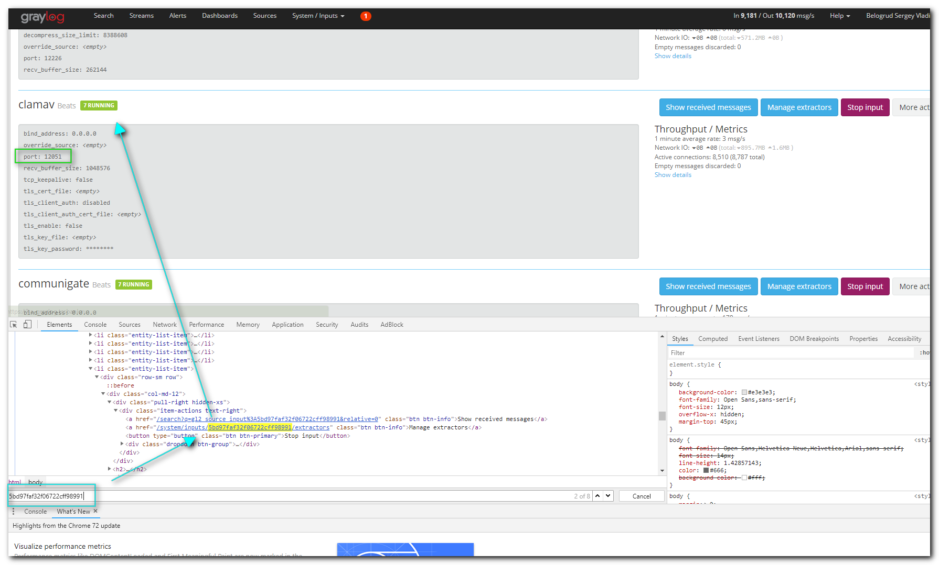
# The same port is in our filebeat.yml files
[root@vm-pr-atm-zabbix01p ~]# cat /etc/graylog/collector-sidecar/generated/filebeat.yml
filebeat:
...
output:
logstash:
hosts:
- ha-graylog.tcsbank.ru:12051
...
tags:
- vm-pr-atm-zabbix01p
- clamav
[root@vm-pr-atm-zabbix01p ~]#

# I thought - that’s wrong rule.
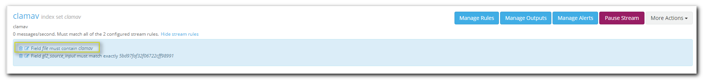

# I have change it to follow. Instead “file” I used “tags”.
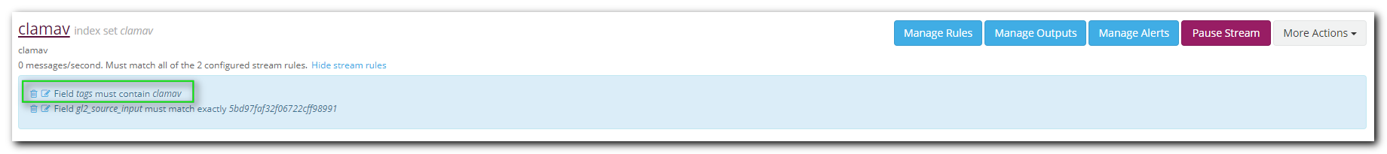

#
# To generate some data, I went to one of servers and run follow command to make a file, that could be sent to graylog.
#
[root@m1-prt-prod-api01 ~]# tail /var/spool/cron/root
# SALT_CRON_IDENTIFIER:python /etc/zabbix/plugins/api_executors_values.py>>/var/log/zabbix/zabbix_sender.log
*/1 * * * * python /etc/zabbix/plugins/api_executors_values.py>>/var/log/zabbix/zabbix_sender.log
# SALT_CRON_IDENTIFIER:python /etc/zabbix/plugins/api_executors_keys.py>>/var/log/zabbix/zabbix_sender.log
*/10 * * * * python /etc/zabbix/plugins/api_executors_keys.py>>/var/log/zabbix/zabbix_sender.log
# SALT_CRON_IDENTIFIER:collect_connections
* * * * * /root/bin/connectlog
# SALT_CRON_IDENTIFIER:check salt-minion
* */2 * * * if ! ps aux | grep salt-minion| grep -v grep; then /sbin/service salt-minion restart && /usr/sbin/service salt-minion restart; fi > /dev/null
#Ansible: ClamAV UPDATE&RUN
30 1 * * 7 sudo /usr/bin/freshclam --config-file=/etc/clamav/freshclam.conf ; sudo /usr/bin/clamscan --database=/var/lib/clamav --exclude-dir='^/sys|^/proc|^/dev|^/bin|^/sbin' --infected --recursive=true --remove=false -l /var/log/clamav/clamav.log --exclude-dir='^/mnt/pfm_images|^/mnt/pfm_images/operations|^/mnt/mortgage|^/mnt/swift_documents|^/mnt/applicant_photo|^/mnt/sme_docs_api|^/mnt/cards_images|^/mnt/insurance|^/mnt/os_dump|^/mnt/recognition|^/mnt/all_pdf|^/mnt/all_pdf2|^/mnt/integration_recognition|^/mnt/application_selfie|^/mnt/client_avatars|^/mnt/integration_recognition2' /
[root@m1-prt-prod-api01 ~]# /usr/bin/freshclam --config-file=/etc/clamav/freshclam.conf
Fri Mar 22 19:31:51 2019 -> *Current working dir is /var/lib/clamav
Fri Mar 22 19:31:51 2019 -> *Max retries == 3
Fri Mar 22 19:31:51 2019 -> ClamAV update process started at Fri Mar 22 19:31:51 2019
Fri Mar 22 19:31:51 2019 -> *Using IPv6 aware code
Fri Mar 22 19:31:51 2019 -> *Querying clamavdb.tcsbank.ru
Fri Mar 22 19:31:51 2019 -> ^Can't query clamavdb.tcsbank.ru
Fri Mar 22 19:31:51 2019 -> ^Invalid DNS reply. Falling back to HTTP mode.
Fri Mar 22 19:31:51 2019 -> *If-Modified-Since: Wed, 07 Jun 2017 21:38:10 GMT
Fri Mar 22 19:31:51 2019 -> Reading CVD header (main.cvd): Fri Mar 22 19:31:51 2019 -> *Connected to clamavdb.tcsbank.ru (IP: 10.216.42.6).
Fri Mar 22 19:31:51 2019 -> *Trying to retrieve CVD header of http://clamavdb.tcsbank.ru/main.cvd
Fri Mar 22 19:31:51 2019 -> OK
Fri Mar 22 19:31:51 2019 -> main.cvd is up to date (version: 58, sigs: 4566249, f-level: 60, builder: sigmgr)
Fri Mar 22 19:31:51 2019 -> *If-Modified-Since: Thu, 21 Mar 2019 07:52:58 GMT
Fri Mar 22 19:31:51 2019 -> Reading CVD header (daily.cvd): Fri Mar 22 19:31:51 2019 -> *Connected to clamavdb.tcsbank.ru (IP: 10.216.42.6).
Fri Mar 22 19:31:51 2019 -> *Trying to retrieve CVD header of http://clamavdb.tcsbank.ru/daily.cvd
Fri Mar 22 19:31:51 2019 -> OK
Fri Mar 22 19:31:51 2019 -> *Retrieving http://clamavdb.tcsbank.ru/daily-25396.cdiff
Fri Mar 22 19:31:51 2019 -> *Trying to download http://clamavdb.tcsbank.ru/daily-25396.cdiff (IP: 10.216.42.6)
Fri Mar 22 19:31:51 2019 -> Downloading daily-25396.cdiff [100%]
Fri Mar 22 19:31:51 2019 -> *cdiff_apply: Parsed 1701 lines and executed 1701 commands
Fri Mar 22 19:31:52 2019 -> *Loading signatures from daily.cld
Fri Mar 22 19:32:15 2019 -> *Properly loaded 1528057 signatures from new daily.cld
Fri Mar 22 19:32:15 2019 -> daily.cld updated (version: 25396, sigs: 1528057, f-level: 63, builder: raynman)
Fri Mar 22 19:32:15 2019 -> *If-Modified-Since: Wed, 02 Jan 2019 14:42:37 GMT
Fri Mar 22 19:32:15 2019 -> Reading CVD header (bytecode.cvd): Fri Mar 22 19:32:15 2019 -> *Connected to clamavdb.tcsbank.ru (IP: 10.216.42.6).
Fri Mar 22 19:32:15 2019 -> *Trying to retrieve CVD header of http://clamavdb.tcsbank.ru/bytecode.cvd
Fri Mar 22 19:32:15 2019 -> OK
Fri Mar 22 19:32:15 2019 -> bytecode.cvd is up to date (version: 328, sigs: 94, f-level: 63, builder: neo)
Fri Mar 22 19:32:19 2019 -> Database updated (6094400 signatures) from clamavdb.tcsbank.ru (IP: 10.216.42.6)
[root@m1-prt-prod-api01 ~]#

#
# Very soon I have seen new messages!
